10/6/2026


IT510 Capstone Semester 2 Year 2026

Self-management review
  - Project Title: AI-Enhanced vs Legacy Digital Forensics and Investigation Tools – A Comparative Efficacy Analysis
  - Team Name: Byte Harbor Butchers
  - Team Members: Dave Sushames, Olivia Hey, Matt Baker, Sam Davies
  - Project Client: Geoff Gordon
  - Whitireia and WelTec
Contents
Reporting period 1: Week 1 to Week 4 2
Meeting agenda & minutes with Client 2
Meeting agenda & minutes with Advisor 3
Gantt Chart 3
Team Weekly Report 4
Dave Sushames – Week 4 Individual Log 5
Samuel Davies – Week 4 Individual logbook Discussion 5
Olivia Hey – Week 4 Individual Logbook Evidence Discussion 6
Matt Baker – Week 4 Individual Logbook Evidence Discussion 6
Reporting period 2: Week 10 to Week 12 7
Meeting agenda & minutes with Client 7
Meeting agenda & minutes with Advisor 7
Gantt Chart 8
Team Weekly Report 8
Dave Sushames – Week 10 Individual Log 9
Samuel Davies – Week 10 Individual Logbook Discussion 10
Olivia Hey – Week 10 Individual Logbook Evidence Discussion 11
Matt Baker – Week 10 Individual Logbook Evidence Discussion 12
Appendices 13
Appendix A – Client Meeting Minutes/Agenda Period 2 Evidence 13
Appendix B – Advisor Meeting Minutes/Agenda Period 1 Evidence 14
Appendix C – Advisor Meeting Minutes/Agenda Period 2 Evidence 16
Appendix D – Gantt Chart Period 1 Evidence 18
Appendix E – Gantt Chart Period 2 Evidence 19
Appendix F – Team Weekly Report Period 1 Evidence 20
Appendix G – Team Weekly Report Period 2 Evidence 22
Appendix H – DS Weekly Individual Log Period 1 Evidence 23
Appendix I – DS Weekly Individual Log Period 2 Evidence 24
Appendix J – OH Weekly Individual Log Period 1 Evidence 28
Appendix K – OH Weekly Individual Log Period 2 Evidence 32
Appendix L – MB Weekly Individual Log Period 1 Evidence 37
Appendix M – MB Weekly Individual Log Period 2 Evidence 42
Appendix N – SD Weekly Individual Log Period 1 Evidence 59
Appendix O – SD Weekly Individual Log Period 2 Evidence 63

Reporting period 1: Week 1 to Week 4

Meeting agenda & minutes with Client

Experience
The team does not have any meeting minutes or an agenda with the Client Geoff Gordon from the first 4 weeks. Our Capstone Manager was Dave Sushames at the time, who would schedule meetings through email which is the standard way of doing so. However, most of the work the team did in the first four weeks of Capstone was very practical and hands-on rather than any online or formal in-person meeting.
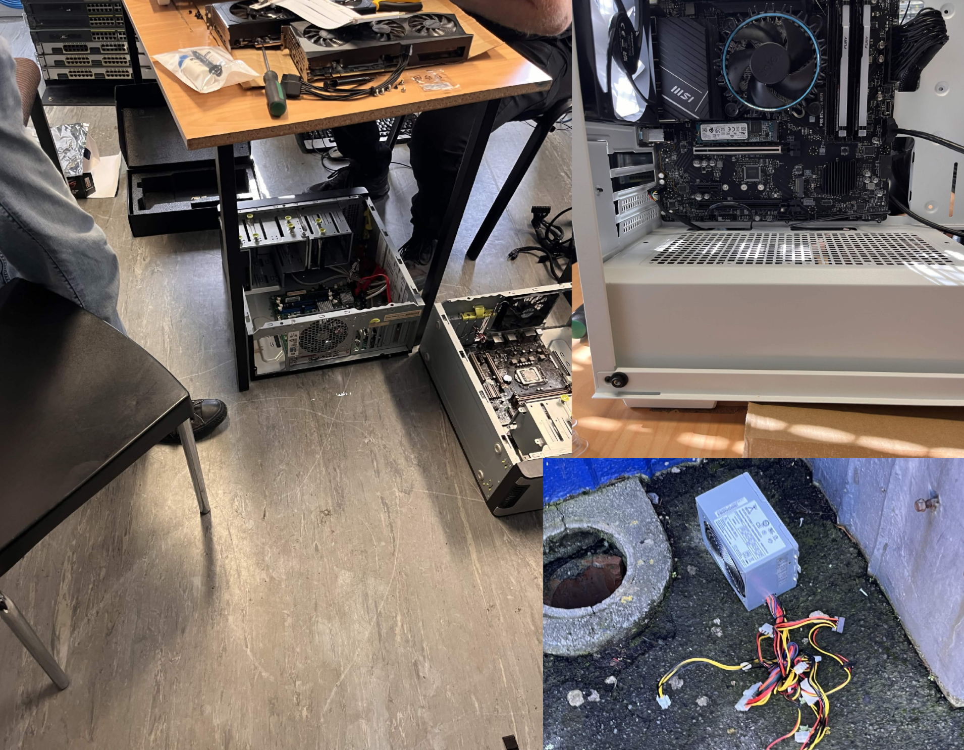

Reflection
In hindsight, the team should have been writing meeting notes and preparing meeting agendas for Geoff even though our meetings were quite informal. Meeting notes and agendas function as a record that the meeting occurred and this grew increasingly more important as the project developed, especially with respect to writing logbooks. It is also important that records in the form of agendas and minutes exist as evidence. Meeting notes with the client also augment the ability of the team to understand and satisfy the requirements of the client more completely. In our case, areas for research or investigation that Geoff mentioned in passing during the opening weeks could have been a source to refine or refer to what he expects out of this project.

Action
The action going forward was to have someone on our team be assigned to making the meeting agenda and notes for meetings with our client. The initial note taker was Olivia Hey, to be replaced by Dave when Olivia was made the new Project manager. This compartmentalisation of work increased the likelihood that note taking would be carried out reliably. A designated note taker holds full responsibility and is accountable when this task is not completed. For a future project, assigning a notes taker from the very beginning, and not cycling the role, would serve the same desired outcome.

Meeting agenda & minutes with Advisor
Evidence of advisor meeting notes taken during the concerned period can be found in Appendix A – Client Meeting Minutes/Agenda Period 2 Evidence

Experience
These notes were written by Olivia, at the time when Dave was still project manager. Olivia was taking a notepad into the meeting and writing them down physically. Matt would then digitize these into the meeting minutes template. This was the week in which the Proposal was due. These notes required extra time to write up, owing to the aforementioned necessity of digital conversion. This method was preferred as it allowed the team to remain focussed on the meeting and discussion with our advisor Clement Swarnappa as it was happening.

Reflection
The biggest problem is that during this meeting, Clement directly mentions the notes which are documented below and then his feedback is not followed up on for this set of notes.
“-Proper decorum when organizing meetings”
“-Agenda should be provided beforehand, meeting minutes after for signing”
“-Send as word documents in email”
“-Have meeting 1 and 2 signed before meeting 3”
All of these notes imply that something went poorly during the email communications. This would have been Dave’s responsibility at the time, but the rest of the team could have collectively voted to change the Project Manager role earlier than they did because this problem was addressed but nothing ended up happening. These notes are also missing the signature from Clement. A thing the team did well on with notetaking is that the timestamps and template are used consistently and well.

Action
In the future, the Project Manager should use a calendar notification to remind themselves to email beforehand and also further follow up with the meeting attendee’s so that these steps turn into a habit and each meeting gets more consistent. It may also be of benefit to have the team members do the same so that the team may remind each other.

Gantt Chart
Evidence of the Gantt chart created during this period can be found in Appendix D – Gannt Chart Period 1 Evidence

Experience
This Gantt chart was made before our final version of the proposal was handed in and as such, our Gantt chart does not reflect the path that was taken. For example, “Run tests” or “Design test environment” were written as tasks prior to the project scope being changed. Reports can be compared using metrics, and can be refined and reviewed, but they cannot have test cases run on them the way that code can.
The proposal heavily changed over the course of two weeks as the project was guided by our technical advisor Dr Bryce Antony. The original focus behind the project was to test DFIR tools that use AI to perform the same core-functionality as traditional tools for a direct comparison. However, testing these tools over the course of the earlier weeks lead to discovering that these tools do not exist in the way they were imagined. The aim of the proposal shifted to testing the AI output of reports when given the same dataset results as a forensic examiner and as such, the Gantt chart does not look the same way it did anymore.

Reflection
The Gantt chart was broadly limited in usefulness to the team at this point. A lot of changes have been made to it due to the shift in project direction, and the lack of consistency with the chart has not helped. The team were not checking nor updating the chart often, so it has not been as helpful as it could have been. For the team, reasons for accessing the Gannt chart were limited to checking what team members should be working on, and what tasks the team stated that the team would do, as a source of accountability. This purpose was shared with the proposal.

Action
The Gantt chart should be regularly checked and updated. Tasks and milestones should better reflect the actual situation. This would help the team know what tasks have the highest priority, guiding them as to what to work on to meet the milestones.

Team Weekly Report
Evidence of a weekly team report taken during the concerned period can be found in Appendix F – Team Weekly Report Period 1 Evidence

Experience
The team always holds a team meeting at the beginning of the week on either a Monday or Tuesday. During these meetings, Dave consolidates the team’s hours that they prepared the day before into the Weekly Report. This meeting time is used to check that the records written within the weekly report correctly add up and remain consistent across the team.

Reflection
Doing the group report during a team meeting was helpful, as any discrepancies between the team members’ times can be checked and corrected on the spot. During the first few weeks, the team missed a weekly log submission, which resulted in the need to use the correction point. If the team had submitted logs on time, there would have been no need to do this. This failure meant any future late submissions would not be able to be uploaded and result in a week of missing logs for the whole team.

Action
In the future, the Project Manager should set a reminder before the due date to turn in the group logs. This should prevent any future group logs from missing the deadline.

Dave Sushames – Week 4 Individual Log
This discussion references the content found in Appendix H – DS Weekly Individual Log Period 1 Evidence

Experience
In week 4, I took charge of the Risk Assessment, Mitigation, and Contingency tables for the proposal, as well as the Gantt chart. Taking inspiration from Matt’s documentation layout, I started writing my logs in a similar format, with the exact hours of when work took place. At this point, the team were looking for a way of working collaboratively on the same files, so I showed the team how to use Git.

Reflection
I did not work enough hours this week. With only 17 hours 15 minutes, there was a lot more time I could have spent on different parts of the proposal. When I did the maths, 450 hours over 17 weeks was at least 26.5 hours per week. My running total was only 40 hours, which was behind where it should have been. As I was only doing 17:45 hours by week 4, it wasn’t enough. I feel that if I had put more hours into the proposal, our team would have gotten a better grade for it.

Action
After this week, I committed to doing more hours per week. Each week, I worked out how many hours I needed using the formula [(450 - Running total) / weeks left], and aimed to do at least that many hours in the coming week. From this point onwards, my weekly hours

Samuel Davies – Week 4 Individual logbook Discussion
This discussion relates to the evidence present in Appendix N – SD Weekly Individual Log Period 1 Evidence

Experience
During this week we had a lapse in work that we could be doing as around this time in the project we were still finding our footing in the project. Therefore, this week I took it upon myself to do a lot of research into AI concepts to make sure that I properly understood AI’s role in our project and would be able to contribute. This week I also noted that I had a lack of detail in my logbook’s that I had noticed due to comparing myself to the logbooks of my team members and from this point forward decided to bring more comprehensive logbooks due to the example that they had set.

Reflection
I did not get enough hours during this week; however, I believe this is partly due to the fact that the project had not realty kicked off yet and I felt there was not much to do, and I tried to fill that gap by doing as much research as I could without feeling as if I was researching things that were maybe not as useful to the project. If I could go back to week One and do this project again, I would do my best to get as much research about our topic done as possible.

Action
At this point in time, I made a commitment that I wanted to be hitting 30 hours per week, which I understand to this point is the standard that we are supposed to be hitting per week regardless however given that around this time our AI PC was running I was more confident I would be able to hit this number. This week I also made the commitment to making sure my logs looked better.

Olivia Hey – Week 4 Individual Logbook Evidence Discussion
This section will discuss the evidence presented in Appendix J – OH Weekly Individual Log Period 1 Evidence

Experience
During the week where these logbooks were being created, I was still writing down time in five-minute chunks. This set of logbooks are also missing the additional time marker that is added in later weeks next to the day and time for each entry. I keep a handwritten diary of all my notes across every week including the date and time for every entry I plan to add to the log at the end of the week. This requires me to write up the digital version of the weekly log as I essentially write up the weekly log during the week on a physical book. The documents template remained the same up until the later weeks with each team member following the same template with only minor structure differences I the evidence sections.

Reflection
A handwritten diary isn’t a completely inconvenient method of writing down time logs in the moment, but it is inconvenient at the end of the week when the other team members have formulated theirs during the week and then need to wait for me to digitise mine before creating the weekly group log. Writing down time in five-minute chunks was a complete waste of time and an overexertion of energy for everybody involved. Not writing down additional time markers costed more time in the long-run with calculations.

Action
While these were problems faced in the fourth week, by the later weeks I adjusted the documentation to make it easier on myself and the team to calculate hours. Keeping documentation consistent will allow for templates to be easily reused and make the working process vastly more efficient.

Matt Baker – Week 4 Individual Logbook Evidence Discussion
This discussion relates to the evidence present in Appendix L – MB Weekly Individual Log Period 1 Evidence

Experience
I desired to lead by example the entire way through this project by creating my logs with the most consistent, comprehensive, and well documented practice. Within the context of week 4, despite there not being enough work, I established and maintained timestamps and formatting that would carry through the entire project, including providing the hours per activity making adding up the hours at the end of the week easier.

Reflection
I didn’t get enough hours; I had not created enough work for myself in the week. Leading by example means doing more and higher quality work than everyone else, and on top of that, having the most reliable documentation the team would use to benchmark when it came time to audit these logs during a meeting.

Action
I made a commitment around this point to always attempt to get more hours than I got in the previous week. The hours of work I do is a variable under my control, the final outcome of a project involving four people is not. This could serve as a primary factor as to why my logs are paid attention to in the team.

Reporting period 2: Week 10 to Week 12

Meeting agenda & minutes with Client
Evidence of client meeting notes taken during the concerned period can be found in Appendix A – Client Meeting Minutes/Agenda Period 2 Evidence

Experience
The only meeting we had with Geoff during this period occurred as the mid-project progress presentation in week 10. At this time, the team was focused with being present during this presentation, and as it was being recorded, allowed us to produce the notes post-hoc.

Reflection
The positive thing about the notes are the timestamps for each topic and the consistent use of a template. These notes appear to be lacking the agenda for the meeting and the signature from the client. This is notably something which the team should be paying attention to because it is more consistent within advisor notes but did not occur for this client meeting. Some of the wording is informal, and the action item/deliverables table is not used whatsoever. Because the team had a meeting with Geoff on the Friday of the week prior to prepare him for the mid-project progress presentation it can be said that an agenda was not as useful, Geoff knew what the purpose of the presentation was and that he may be asked questions. The presentation itself and included topic list served as a de-facto agenda.

Action
The team should consider removing tables from the set meeting notes if they remain unused. A standard should be put in place that all notes should be held to, so that they remain consistent. This would entail asking for the client’s signature and double checking completed documents to make sure the notes are meeting the set standards.

Meeting agenda & minutes with Advisor
Evidence of advisor meeting notes taken during the concerned period can be found in Appendix C – Advisor Meeting Minutes/Agenda Period 2 Evidence

Experience
In this set of meeting notes, the advisor Clement has signed approval and there is a clear, scheduled agenda with initials and time allowances for each agenda item. The meeting notes themselves have attached timestamps and are clearly understandable. This document was produced with respect and consciousness to the specific preferences of Clement, those being an agenda delivered before the meeting, and a returned copy of the meeting notes to be signed by him to validate that the recorded experience is acceptable to all parties.

Reflection
The only improvement that could possibly be made is removing the action item and deliverable box because it is empty and taking up space, reducing clarity. For the most part, there is not much room to improve.

Action
Keep the following sets of notes as consistent as this set is. This can be done by having the same person writing the notes for every meeting if they are available and prepare them with the same method.

Gantt Chart
Evidence of the Gantt chart created during the concerned period can be found in Appendix E – Gantt Chart Period 2 Evidence

Experience
The week 10-12 Gantt chart is an updated version of the Gantt chart, as the stages of the project had changed and developed. More tasks have been included and the timeline has shifted, as there is no longer any testing of tools that needs to be done, and is now creating reports. Compared to the first version, there are a rough estimate of 10 new event additions altogether.

Reflection
The new additions give a sense of the timeline that is left, and better suit the actual work that needs to be done. While our project does not have sprints or clearly defined sections that a development project would have (eg. Design, Development, Testing), separating the tasks into groups aided in visibility.

Action
In the future, the team member in charge of maintaining the Gantt chart should make sure to check and update the chart on a regular basis, possibly during the weekly team meetings. This would make sure that it stays in line with the scope of the project.

Team Weekly Report
Evidence of a weekly team report created in the concerned period can be found in Appendix G – Team Weekly Report Period 2 Evidence

Experience
In Week 11, the template for the group weekly logs remains the same. Team members that were recording in 5-minute chunks have begun recording times in 15-minute chunks which greatly reduces the amount of time it takes to calculate log hours, reduces confusion, and is also the method specified in official course documentation. This a change that should have been realised in the first 4 weeks but was not. These logs have a small error in that they are missing the ‘h’ and ‘m’ marks for a handful of columns.

Reflection
Reflecting on this, team members that used 5-minute chunks should have implemented this change sooner as this could have streamlined the process and made things easier for the team through all the logs that the team had submitted. Should the team have recognised this failure at the beginning of the course the team would have implemented the necessary changes to stop this issue from occurring again.
There was some confusion as the team was told to use 15-minute chunks, but the research log example the team was given featured 5-minute chunks. As a result, the research log has been split into 5-minute chunks, while all other hours were measured in 15-minute chunks.

Action
Going forward this issue has been addressed and things have been done correctly in the weeks following week 11. This means that from week 11 every weekly individual log has been created using 15-minute chunks instead of 5-minute chunks.
In the future, the team should check early on with the Capstone Project Coordinator whether the research minutes should be chunked into 5 minutes or 15 minutes, to clear up the confusion.

Dave Sushames – Week 10 Individual Log
This discussion references the content found in Appendix I – DS Weekly Individual Log Period 2 Evidence

Experience
In week 10, we had an advisor meeting with Clement to discuss the weekly logs that Sam and I had not turned in. We came up with a few options for Olivia to present Dr Dax with, in the hopes that we could still turn them in. We did our mid-project presentation to Geoff, which went well. I rebuilt the LLM model with parameters more suited to DFIR work, and made a version of the Foremost script so that it would use tools like pdfcrack and steghide to extract encrypted information, but when I messaged Bryce he said this should be a stretch goal, and just report on the direct Foremost output. I also figured out a method to stop the LLM output from adding ANSI characters on the end of each line, by calling Ollama’s API directly instead of using the ollama run CLI.

Reflection
Missing my week 8 log deadline was a shock, and a wake up call. It had been written and audited with the team, but I forgot to upload it until after the dropbox had closed. Despite us coming up with some reasonable sounding alternatives, we were told that we couldn’t turn in the missed logs, and should reflect on them in the Self-Management Review. I spent all of Thursday working on an assignment for my other class, so I feel the lower amount of hours this week is justifiable. Setting the model’s parameters was an important step, that honestly could have happened earlier.
Finding out that using pdfcrack and steghide wasn’t required until after I had already done the work was frustrating as I had essentially wasted several hours, and highlighted the importance of understanding the project requirements before spending time on it.
Matt had found another way of resolving the ANSI characters by using a –nowordwrap flag in the command, which also invalidated the hours I had spent with the API. This emphasized the importance of communication within the team when working on similar tasks.

Action
After this week, I committed to upload each weekly log as soon as auditing was finished, rather than waiting for Wednesday to upload. I also decided to check with the team or with Bryce before starting any work, to make sure that it was actually required and not a stretch goal, as well as telling the team exactly what I was working on to prevent duplicated work. I know I have another assignment coming up for my other class, so I will plan ahead to make sure it doesn’t affect my required capstone hours when it comes up.

Samuel Davies – Week 10 Individual Logbook Discussion
This discussion relates to the evidence present in Appendix I – DS Weekly Individual Log Period 2 Evidence

Experience
This week was one of my best weeks as I managed to reach the 30-hour mark for hours completed, this was mainly due to the number of meetings we had this week as well as the work on the reports that I was able to complete this week, these reports were really great and enabled me to reach the goal of 30 hours for the week.

Reflection
I was happy with how much work I had completed during this week However, reflecting on the previous weeks, I have a lack of hours completed compared to my peers and is again as a result of not finding myself enough work to do, which is potentially motivated by there not being enough work to do however this is still a problem that I need to work on. Another challenge that I have had with since the week four logs is that I forgot to submit my weekly logs for two weeks, this was as a result of my tardiness and simply forgetting that I had not yet submitted the logs. I also mistakenly thought I could re-submit my logs by using my individual logbook correction point without discussing this action with my project manager which could negatively affect my team during the final panel, which was not my intention.

Action
As a result of me not getting enough hours in the previous weeks I made a considerable effort to get the required hours for week 10. Since attempting to re-submit my logs through the individual logbook correction point without discussing with either my advisor or my project manager we have since co-ordinated between ourselves for a solution to this problem and have remediated my tardiness so this will not happen again in future.

Olivia Hey – Week 10 Individual Logbook Evidence Discussion
This section will discuss the evidence presented in Appendix K – OH Weekly Individual Log Period 2 Evidence

Experience
By Week 10, it had become very routine to make the logbooks. The template became familiar enough to where it wasn’t something where I needed to reference a previous week’s books to keep it consistent. I found it useful to make a copy of the previous weeks document and just remove the stuff that needed changing and kept all the titles that I needed.

Reflection
It has been helpful that the template has remained consistent with minimal changes because it has reduced overall time creating the document each week, allowing me more time to focus on other matters. Adding in time markers next to the day and time has reduced time calculating. I considered keeping the table the same but writing the hours down in order of how they were completed during the day (eg. the total Monday hours followed by the total Tuesday hours) but in hindsight, I think keeping it the way it is helps with the categorisation of tasks. I feel as if the format that I am currently using for the logs works for myself.

Action
Keeping the formatting the same as previous weeks through till the end of the project will be the best course of action. How they are written currently is functional and readable, I could do better to write longer descriptions for the activities as I must remember that I am not the only reading these logs and it is difficult to glean information off of a short description.

Olivia Hey - Week 1 Considerations
Advice I would’ve given myself in Week 1 is to spend the first few weeks using research as a means to getting the remaining hours for that week that I haven’t gotten already. The time you spend earlier in the semester will become vitally important down the line as doing more hours in a week is feasibly possible, but you’ll be forced to value the breaktime you get. The second piece of advice is to have spoken with Rebecca Burns earlier as she is massively helpful and learning support services can help with more than just learning problems. The last piece of advice is to change the project manager if there are problems rather than avoid the problem entirely. It will become an issue if problems aren’t addressed.

Matt Baker – Week 10 Individual Logbook Evidence Discussion
This discussion relates to the evidence present in Appendix M – MB Weekly Individual Log Period 2 Evidence

Experience
Creating and uploading these logs was an exercise in discipline and helped me remain on track with the project. A weekly expectation makes it easier to quantify how much work is realistically able to be achieved. Week 10 was another typically development-heavy week for me as I was working on the core solutions to integrate LLMs with our 3 DFIR tools at this point and had just completed the first solution. Geoff’s input guided me to create lines to calculate and display the total input and output token costs to the user from running these scripts. This was one of the longest logbooks I had created so far.

Reflection
Creating the logbooks at this point was beyond the purposes of simply documentation. It helped me to remember what I had worked on the previous day, what I had tested and desired to work on later, what syntax to use for specific commands, and allowed me to relearn the purpose of certain commands/modules/functions from explanations in my own words. After completing the first solution and knowing I would be referencing my own logs for information as how I can develop future solutions with their contents. The logbook is very long and filled with content and screenshots, but for auditing and in the interest of integrity of work, I figured there could not be too much documentation. The logs at this point were so long that when I added up the hours, I was worried I would miss them.

Action
Knowing I had to create logs going forward with a resolution that made them easier for me to personally reference enforced a desire to write explanations with foresight. I also at this point started boldening the hourly count so that when adding up my hours I can find them easier and not potentially miss them.

Appendices

Appendix A – Client Meeting Minutes/Agenda Period 2 Evidence
BHB Meeting Agenda
DATE: 11/09/26 | TIME: 10:00
LOCATION: Remote Meeting via Zoom
ATTENDEES: Geoff Gordon, Dave Sushames, Matt Baker, Olivia Hey, Sam Davies
APOLOGIES: n/a | NON-ATTENDEE(S): n/a
MEETING LEADER: | MINUTES TAKER: Dave Sushames

PROJECT NAME: AI-Enhanced vs Legacy Digital Forensics Tools – A Comparative Efficacy Analysis
PROJECT PURPOSE: Provide an empirical analysis on Ai-augmented digital forensics technologies
MEETING PURPOSE: First Geoff meeting in a while.

AGENDA ITEM: | LED BY (Initials Only): | TIME  ALLOTTED:
1. Apologies | N/A | N/A
2. Action items from previous minutes | N/A | N/A
3:
4:
5:
6:
7:
8: Any other business
9: Assigning next meeting date and time

ACTION ITEM: | DELIVERABLE(S):

MEETING NOTES: Geoff 11/09
1000 Greetings, explaining what the mid project presentation is about
1010 Discussing change in project scope, Bryce’s suggestions
1020 AI is a challenge to get it to work with DF tools, so the answer to the project is probably “no”, we just have to justify that answer.
1030 Limitations of AI, Snellen charts. Context lengths.
1040 Gemma is good because it has a decent context window. Tool looping is an issue (“I’ll read that again. I’ll read that again. I’ll read-“).
1050 Arranging a time for the presentation.
1100 Discussing project management methodologies, Scrum.
1110 Covering weekly hours.
1120 Pro tips on management techniques
1130 New computers. LLMs have different layers, with each layer on a different machine.
1140 Methods of recovering data. Can’t recover data if you destroy the hard drive.
1150 Advice on doing the presentation
Meeting ended 1200

DETAILS OF NEXT MEETING:
DATE: | TIME: 1000
LOCATION: Discord
MEETING CLOSED: 1200

Appendix B – Advisor Meeting Minutes/Agenda Period 1 Evidence
BDSH Advisor Meeting Minutes (Week 4)
DATE: 06/08/26 | TIME: 12:00PM
LOCATION: T7 Meeting room
ATTENDEES: Clement Swarnappa, Dave Sushames, Matt Baker, Olivia Hey, Sam Davies
APOLOGIES: N/A | NON-ATTENDEE(S): N/A
MEETING LEADER: Dave Sushames, Matt Baker | MINUTES TAKER: Olivia Hey

PROJECT NAME: AI vs Legacy Digital Forensics Tools – A Comparative Efficacy Analysis
PROJECT PURPOSE: Provide an empirical analysis on AI digital forensics technologies
MEETING PURPOSE: Find assistance in preparing the project proposal

AGENDA ITEM: | LED BY (Initials Only): | TIME  ALLOTTED:
State of the project, proposal | MB | 15
Find a new methodology, discuss problem of two competing methodology requirements | DS | 15
Clarification on the client contract | MB | 15
Discuss scope and requirements gathered from our previous meeting with geoff | DS | 15

ACTION ITEM: | DELIVERABLE(S):
Generate meeting minutes, adapt a template, send to clement for signing | Meeting minutes with signature section
Select an appropriate simple methodology that we have used previously | Present methodology

MEETING NOTES:
Proper decorum when organizing meetings
-Agenda should be provided beforehand, meeting minutes after for signing
-Send as word documents in email
-Have meeting 1 and 2 signed before meeting 3
Dave will send proposal document after meeting for clement to review
12:20
Clarification on the client contract, says we should send it to Geoff
We don’t have an advisor to talk to about the forensics side of things
12:30
Methodology discussion
-Hybridization is a possibility
- 1 methodology for testing, 1 for project management
- Kanban?
- Dave needs to make project management documents
-Clement likes using Trello for kanban
- research kanban, update methodology section accordingly
12:40
We can use kanban to improve accountability
Discussion about the review panel
- Provide equivalent work to hours contributed
- Annotate research logs for each piece of work
- Create work for ourselves
- Clarify our titles/roles
Next week there is NO MEETING

Ends at 1pm

DETAILS OF NEXT MEETING: Will be Mon/Tue/Weds the week after next
DATE: N/A | TIME: N/A
LOCATION: T7 Meeting room
MEETING CLOSED: 1pm

SIGNATURES
Name: Clement Swarnappa | Role: Advisor | Signature:
Name: Dave Sushames | Role: Project Manager | Signature: Dave Sushames
Name: Matt Baker | Role: Digital Forensics Technician | Signature: Matt Baker
Name: Sam Davies | Role: Digital Forensics Technician | Signature: Sam Davies
Name: Olivia Hey | Role: Digital Forensics Technician | Signature: Olivia Hey

Appendix C – Advisor Meeting Minutes/Agenda Period 2 Evidence
BDSH Advisor Meeting Agenda
DATE: 14/09/26 | TIME: 11:00am
LOCATION: On Campus, Level 7
ATTENDEES: Clement Swarnappa, Dave Sushames, Matt Baker, Olivia Hey, Sam Davies
APOLOGIES: N/A | NON-ATTENDEE(S): N/A
MEETING LEADER: Olivia Hey | MINUTES TAKER: Dave Sushames

PROJECT NAME: AI - Augmented vs Legacy Digital Forensics Tools – A Comparative Efficacy Analysis
PROJECT PURPOSE: Provide an empirical analysis on Ai-augmented digital forensics technologies
MEETING PURPOSE: Advisor meeting for mid project presentation

AGENDA ITEM: | LED BY (Initials Only): | TIME  ALLOTTED:
Introductions | N/A | 5m
Progress update | MB | 15m
Discuss Sam hours | SD | 15m
Mid project presentation | OL | 20m

ACTION ITEM: | DELIVERABLE(S):

MEETING NOTES:
1100 Greetings, basics of mid project presentation.
1105 Presentation is all but ready. Who is doing what work? We’re up to Tenmost now.
1110 Making sure everyone has enough work. Documentation, test cases, reporting. Can share the work around, especially scripts and such.
1115 Design science: Artefacts. Check the marking rubric (ask Dax if there isn’t one). People can dig deep into what artefacts are generated/apply to the project. How frequent should they be, eg 3 per sprint? Follow the methodology.
1120 Standardise the test plan. User, UX, utility testing etc.
1125 Discussing Sam + Dave’s logs.
Option 1: Ask Dax to reopen dropbox.
Option2: Matt/Olivia give up their backup dropboxes?
Option 3: Leave it as it. We can keep the logs for the final panel.
1145 Print the rubric before the next meeting, we can go over it to figure out what needs to be done.
Meeting ended 1200

DETAILS OF NEXT MEETING:
DATE: N/A | TIME: N/A
LOCATION: T7 Meeting room
MEETING CLOSED: 12pm

SIGNATURES
Name: Clement Swarnappa | Role: Advisor | Signature: Clement Swarnappa 16/09/26
Name: Olivia Hey | Role: Project Manager | Signature: Olivia Hey
Name: Matt Baker | Role: Digital Forensics Technician | Signature: Matt Baker
Name: Sam Davies | Role: Digital Forensics Technician | Signature: Sam Davies
Name: Dave Sushames | Role: Tester | Signature: Dave Sushames

Appendix D – Gantt Chart Period 1 Evidence
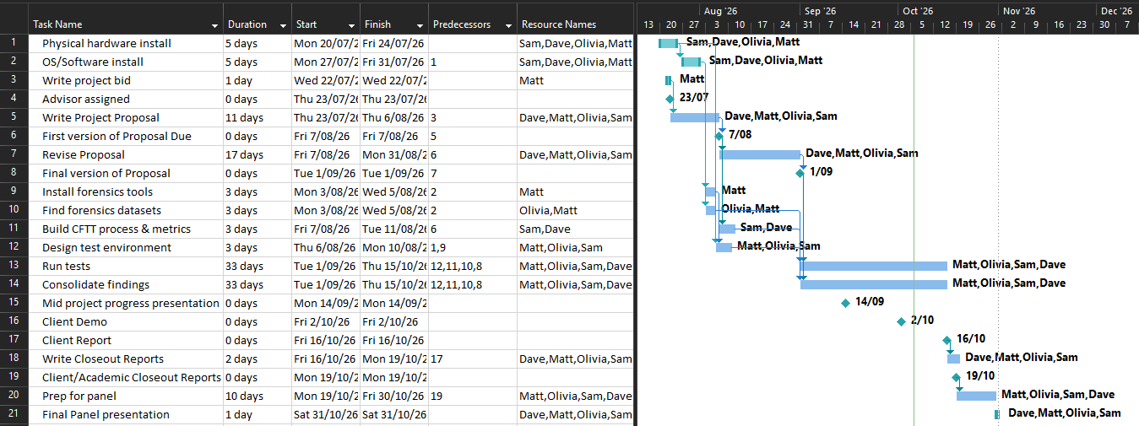

Appendix E – Gantt Chart Period 2 Evidence
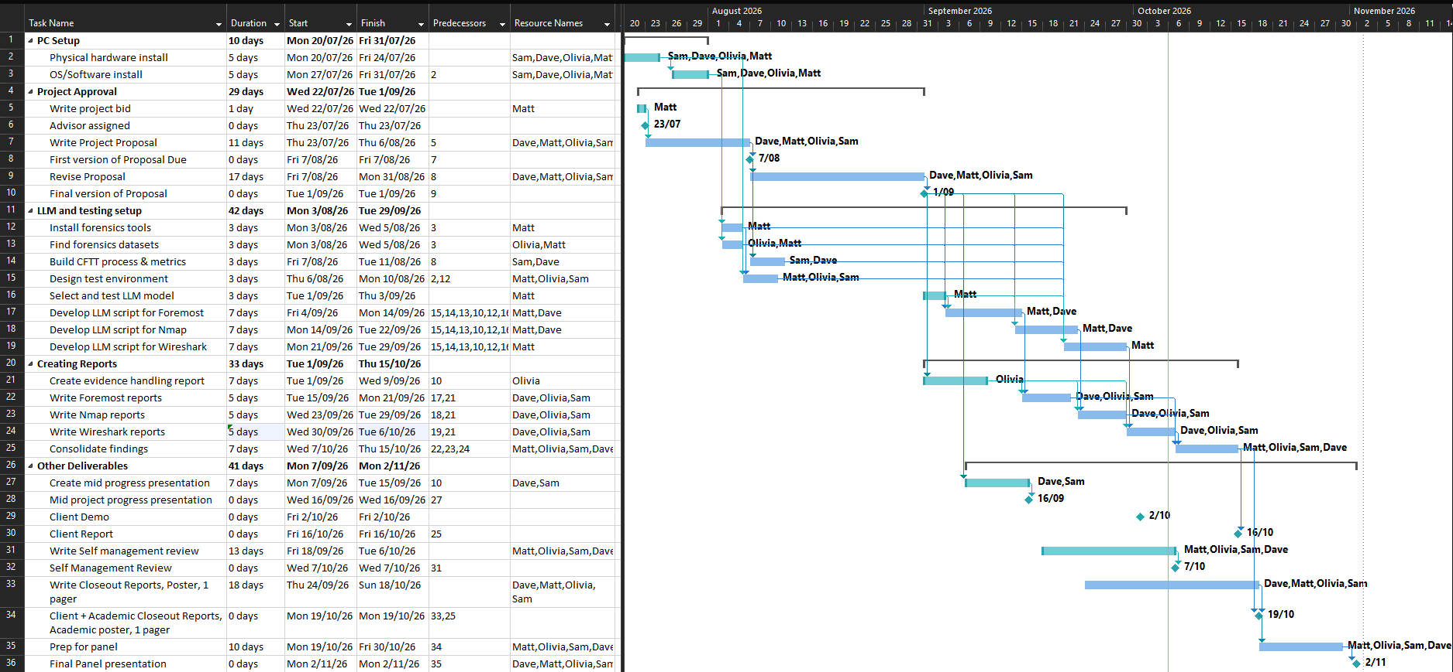

Appendix F – Team Weekly Report Period 1 Evidence
Category | Matt Baker | Sam Davies | Olivia Hey | Dave Sushames | Total hours per category
Team meetings | 4 | 4 | 4 | 4 | 16
Client meetings | 45m | 45m | 45m | 45m | 3
Advisor meetings | 1 | 1 | 1 | 1 | 4
Research | 2h 30m | 12h 35m | 8h 10m |  | 23h 15m
Development | 1 | 1 | 1 | 1 | 4
Testing
Sick Leave
Documentation | 8 | 5 | 6h 45m | 10h 30m | 30h 15m
Other |  |  | 30m |  | 30m
Total hours per team member for this week | 16h 45m | 24h 20m | 22h 10m | 17h 15m | 80h 30m
Running total per team member | 46h 15m | 41 | 46 | 40

Team meetings:
Tuesday 10am – 11:30am. Attempted to have a meeting with Geoff, but he wasn’t able to make it, so we discussed our project proposal and who was covering which sections.
Friday 10:15am – 12:45pm. Group call where we went over the proposal and Dave made last minute edits.
Client meetings:
Wednesday 1:30pm-2:15pm. Recorded meeting with Geoff regarding requirements and deliverables.
Advisor meetings:
Thursday 12pm – 1pm. Meeting with Clement discussing what needs to be kept track of, and how the proposal is going. Sent him the current proposal draft for feedback.
Development:
Showing the team the git repository, catching them up on how git works, showing how to commit/push, and resolve basic merge conflicts.
Documentation:
1 hour each for individual logs.
Work on respective parts of proposal.
Olivia: Project Objective
Sam: Project Plan
Matt: Project Personnel
Dave: Timeline, Risk analysis, Gantt chart.
Other:
Olivia spent 30 minutes editing the video footage from Geoff’s interview.

Appendix G – Team Weekly Report Period 2 Evidence
Category | Matt Baker | Sam Davies | Olivia Hey | Dave Sushames | Total hours per category
Team meetings | 5 | 6h 30m | 6h 30m | 6h 30m | 24h 30m
Client meetings
Advisor meetings | 3h 30m | 3h 30m | 3h 30m | 3h 30m | 14
Research | 2h 30m | 15m | 8h | 2h 50m | 13h 35m
Development | 11h 45m | 10 |  | 12h 15m | 34
Testing | 8h 15m |  |  |  | 8h 15m
Sick Leave
Documentation | 1 | 1 | 9 | 12h 30m | 23h 30m
Other |  |  | 3 |  | 3
Total hours per team member for this week | 32 | 21h 15m | 30h | 37h 35m | V 120h 50m
Running total per team member | 276h 30m | 207h 15m | 254h 30m | 258h 25m

Team meetings:
Monday 1-2:30pm Catching up on what everyone has been doing, assigning tasks for this week.
Tuesday 10-12pm: Discussed work to be done, audited weekly logs.
Thursday 1-3pm: Assigning tasks: Matt demonstrating JSON and CSV files as different methods of LLM integration. Olivia is doing the Review. Dave is doing the Poster.
Friday 10:30-11:30: Debrief after Bryce’s meeting, discussing how to work on the scripts.
Client meetings:
Advisor meetings:
Tuesday 9-10: Bryce meeting discussed accessing Bryce’s network for Nmap scanning. Deciding a good program to make the poster in, as Publisher is discontinued in October.
Friday 8-10:30 Bryce meeting. Discussed Matt’s scripts, standardising files, and converting the AI reports into a more readable format.
Documentation:
1 hour each for individual logs.

Appendix H – DS Weekly Individual Log Period 1 Evidence

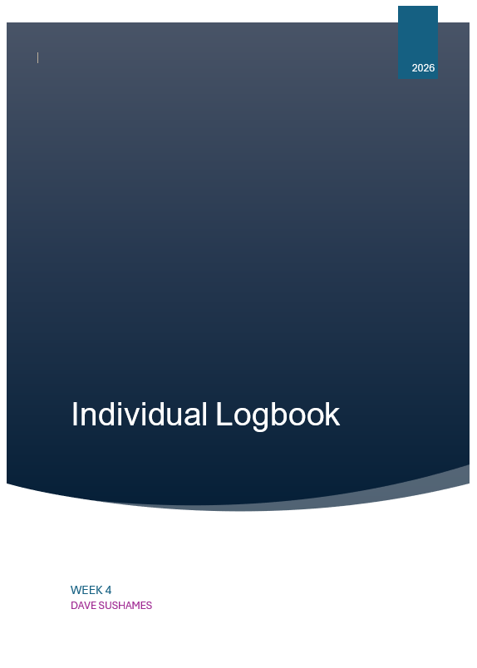
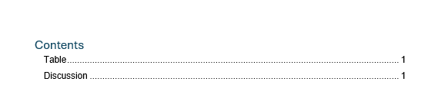

Table
Category | Hours Completed
Team meetings | 4
Client meetings | 45m
Advisor meetings | 1
Research
Development | 1
Testing
Documentation | 9h 30m
Logbook preparation | 1
Other
Total hours for this week | 17h 15m
Running total of hours completed for Capstone | 40

LOGBOOK CONTENT NOTES:
Team meetings:
Tuesday 10am – 11:30am. Attempted to have a meeting with Geoff, but he wasn’t able to make it, so we discussed our project proposal and who was covering which sections.
Friday 10:15am – 12:45pm. Group call where we went over the proposal and I made last minute edits.
Client meetings:
Wednesday 1:30pm-2:15pm. Recorded meeting with Geoff regarding requirements and deliverables.
Advisor meetings:
Thursday 12pm – 1pm. Meeting with Clement discussing what needs to be kept track of, and how the proposal is going. Sent him the current proposal draft for feedback.
Development:
Monday 2:30 – 3:30. 1 hr meeting to teach the team how to use git.
Documentation:
Monday 10am – 12pm, 1pm – 2:30pm. Worked on the risk assessment section of the proposal.
Wednesday 10am-1pm, 2:30pm – 4pm. Finished off the Risk mitigation and contingency plans, started on the Gantt chart.
Thursday 10:30am – 12pm. Finished the Gantt chart.

Appendix I – DS Weekly Individual Log Period 2 Evidence
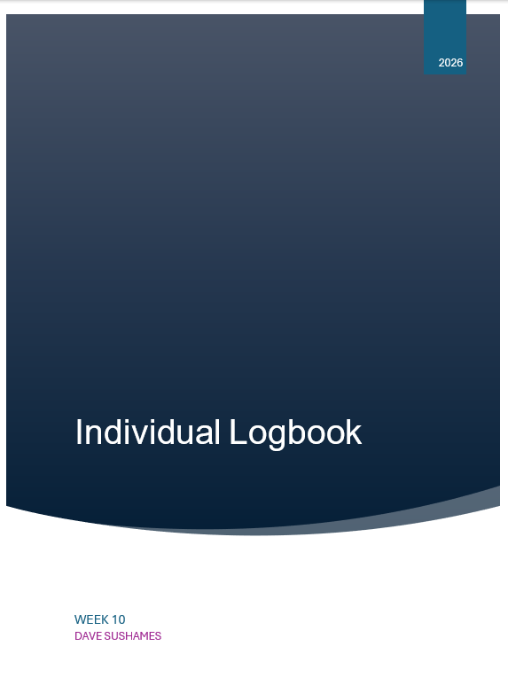
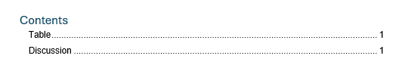

Table
Category | Hours Completed
Team meetings | 5
Client meetings | 1h 15m
Advisor meetings | 5
Research | 2h 20m
Development | 4h 30m
Testing | 2h 45m
Documentation | 4h 15m
Logbook preparation | 1
Other
Total hours for this week | 26h 5m
Running total of hours completed for Capstone | 220h 50m

LOGBOOK CONTENT NOTES:
Team meetings:
Tuesday 9-2pm: Audited hourly logs, clarified upcoming meeting times. Arranged who would lead each presentation slide, made last minute refinements, did a practice run. Matt demo’d the foremost integration.
Client meetings:
Tuesday 2:30-3:45 Giving presentation to Geoff. Discussion about project progress,. Him giving us permission to do nmap/wireshark scanning on school network. Discussing AI’s limitations.
Advisor meetings:
Monday 8-10: Bryce gave advice for the presentation slides. Discussed inclusion of recent development in nMap. He showed how the network tunnelling through SSH could access his ollama server.
Monday 11-12: Meeting with Clement about presentation, as well as the project’s progress. Discussed mine and Sam’s missing weekly logs. Discussed how to document Olivia’s (PM) portion of the project.
Friday 9-11am: Meeting with Bryce about starting work on the poster and final client deliverables, self-management review, version number updates, and what will happen with mine and Sam’s missing logs.
Research
See research log
Development
Spent some time figuring out how to set and adjust the gemma4:26b model’s parameters, especially setting the temperature to 0. Rebuilt the model as “gemma4-df” using the following parameters: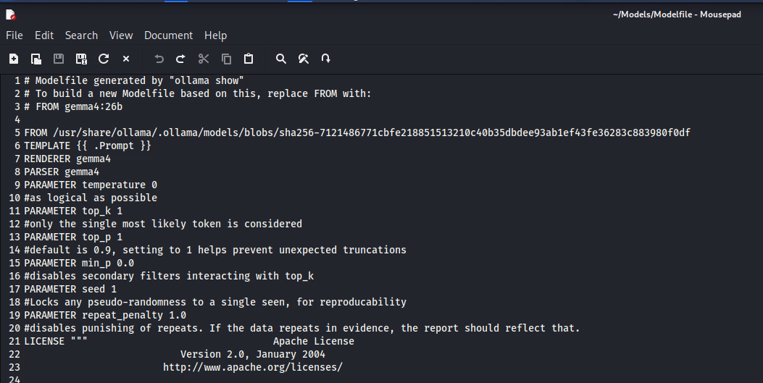
Encountered some issues with permissions, but solved it by adding a new group.
Ran the new model with Matt’s “Ninemost” foremost script, and continued work on a “Tenmost” script where it would attempt to use pdfcrack and steghide to extract encrypted information. In a communication with Bryce, he said this would be more of a stretch goal, so not needed at the moment.
Working on fixing the scripts to fix the end of line ANSI characters.
Testing
Running Nmap scans on my local machine, trying to get a handle on how it works, and how it is useful. 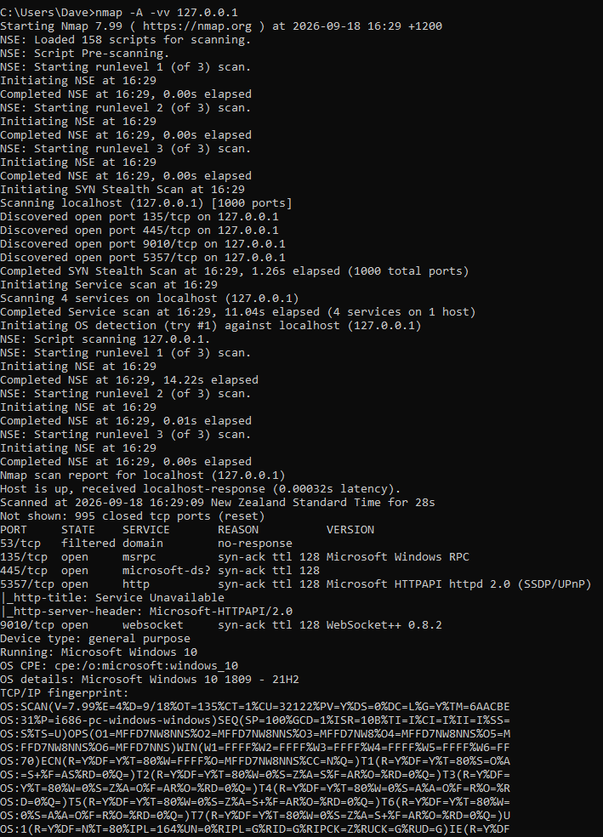
Nmap scans seem to take a very long time, depending on what you’re trying to get them to scan. 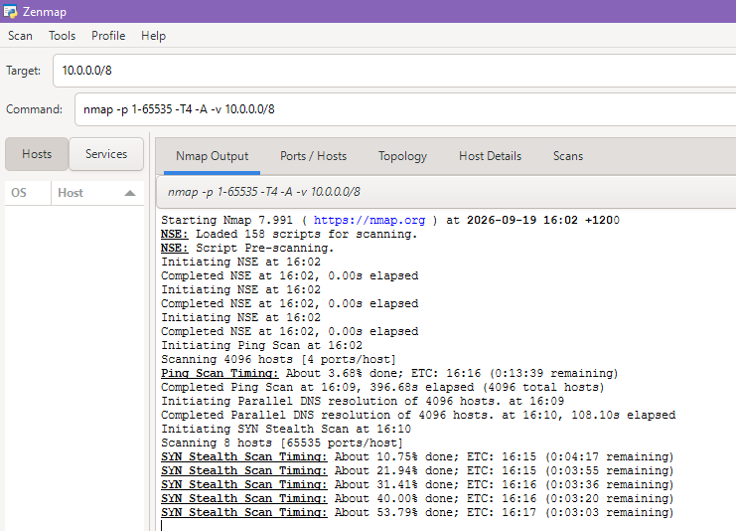
Managed to get an Nmap scan to export to a .txt file
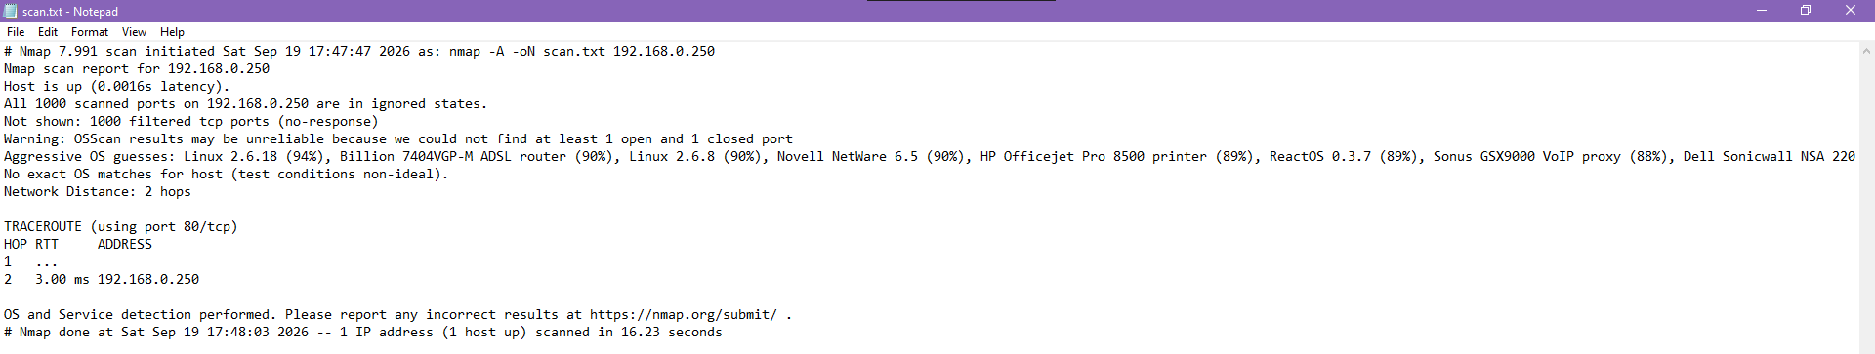
Documentation
Finalising the Mid-project presentation, doing a final pass on formatting.
Started work on the poster for the final panel. Deciding the sections that information would be laid out in.

Appendix J – OH Weekly Individual Log Period 1 Evidence
Week 4 Individual Logbook – Olivia Hey

Hours Breakdown
Category | Hours completed
Team meetings | 4h
Client meetings | 45m
Advisor meetings | 1h
Research | 8h10m
Development | 1h
Testing
Documentation | 5h45m
Logbook preparation | 1h
Sick leave/specific conditions
Other | 30m
Total Hours for this week | 22h10m
Running total of hours completed for  Capstone | 46h/450

Completed Content/Documentation

Team Meetings
Tuesday 10:00am – 11:30am
We were attempting to have our interview with our client Geoff Gordon, but he wasn’t able to make it so we ended up discussing our project proposal instead and who is doing what section.

Friday 10:15am - 12:45pm
We sat in a shared call and we reviewed our proposal document together while Dave screenshared the proposal and edits the document when we gave our inputs.

Advisor Meetings
Thursday 12:00pm – 1:00pm
Advisor meeting with Clement to discuss what we need to be keeping track of and how the proposal is going.

Client Meetings
Wednesday 1:30pm – 2:15pm
We host our interview with Geoff with all members in attendance.

Research
Tuesday 2:30pm – 6:15pm & 6:55pm – 7:55pm
Spent this time watching some webinars from other forensicists about how they use AI in their own work and how we can integrate it into our project.

Wednesday 9:55am – 10:30am
Spent this time looking for datasets that we can use for our project.

Wednesday 11:00am – 11:50am
Watching webinar about incident response event log analysis so I know what sort of things to lookout for- mostly watching this to improve my own ability.

Wednesday 7:20pm – 8:40pm
More webinar watching for improving own forensic ability.

Thursday 3:35pm – 4:15pm
I spend this time looking for and reading documents about mobile phone forensics.

Documentation
Monday 4:00pm – 5:30pm
Working on documenting for the project objective section in our proposal.

Wednesday 10:30am – 10:45am
Making a document so that we can plan and track what parts of the proposal have been done and what needs to be worked on for the group.

Wednesday 2:55pm – 6:10pm
Working on writing my proposal section.

Thursday 4:15pm – 4:50pm
I spend this time working on developing the scope section for our proposal.

Development
Monday 2:30pm – 3:30pm
Spent an hour setting up our groups GitHub repository.
Other
Wednesday 2:10 – 2:40pm
30 minutes editing the video footage from the interview.

Appendix K – OH Weekly Individual Log Period 2 Evidence
Week 10 Individual Logbook – Olivia Hey

Hours Breakdown
Category | Hours completed
Team meetings | 4h 45m
Client meetings | 1h 15m
Advisor meetings | 6h
Research | 4h
Development | 1h 30m
Testing | 45m
Documentation | 11h 45m
Logbook preparation | 1h
Sick leave/specific conditions
Other | 3h 30m
Total Hours for this week | 34h 30m
Running total of hours completed for  Capstone | 224h 30m/450

Completed Content/Documentation

Team Meetings
Tuesday 9:00am – 1:45pm, 4h 45m
Team meeting where we consolidated weekly logs and fixed our inconsistencies, clarified our meeting hours for the week and compare calendar. Rehearsal for mid-project interview and presentation slide editing – fixing grammatical errors.

Advisor Meetings
Monday 8:00am – 10:00am, 2h
Advisor meeting with Dr. Bryce, refer to meeting notes.

Monday 11:00am – 12:00pm, 1h
Advisor meeting with Clement, refer to meeting notes.

Monday 2:00pm – 3:00pm, 1h
Advisor Dr. Dax Roberts, infrequent weekly Capstone team meeting.

Friday 9:00am – 11:00am, 2h
Advisor meeting with Dr. Bryce, self-management review, STARR, versioning, black swan events, Sam/Dave’s weekly log issue, JSON/XML Wireshark output – refer to meeting notes.

Client Meetings
Tuesday 2:30pm – 3:45pm, 1h 15m
Client (Geoff Gordon) mid-project interview, refer to video.

Research
Wednesday 3:30pm – 5:00pm, 1h 30m
Research on if AI can analyse pcaps and a Wireshark podcast – refer to research log.

Wednesday 6:00pm – 8:30pm, 2h 30m
Research on the QUIC protocol – refer to research log.
Development
Sunday 3:15pm – 4:45pm, 1h 30m
THREE.dd, carving the data and structuring the report – reference previous assignment to include artefacts table.

Testing
Sunday 2:30pm – 3:15pm, 45m
Troubleshooting the WinSCP connection to pcadmin (One of the logins for the computer that sits in the networking room).

Documenting
Friday 12:30pm – 3:45pm, 3h 15m
Self-management review making template for the team

Saturday 1:30pm – 6:30pm, 5h
Continuing my self-management review/template, a lot of looking for models of reflection for what one I like, discussing with Matt and Dave about the paster and nmap / remote desktop connection / PuTTy with Matt. Going to classify all this as working on my self-management review though.

Sunday 11:00am – 1:45pm, 2h 45m
Looking for and compiling a visual layout document on OneNote of PhD posters for reference and layout.

Sunday 1:45pm – 2:30pm, 45m
Creating the forensic file and report tracking excel document.

Other
Matter discussed and Approved by Dr Dax Roberts in an email dated 12th of August 2026.

Wednesday 9:00am – 9:30am, 30m
Edited interview video review and hand-in

Appendix L – MB Weekly Individual Log Period 1 Evidence
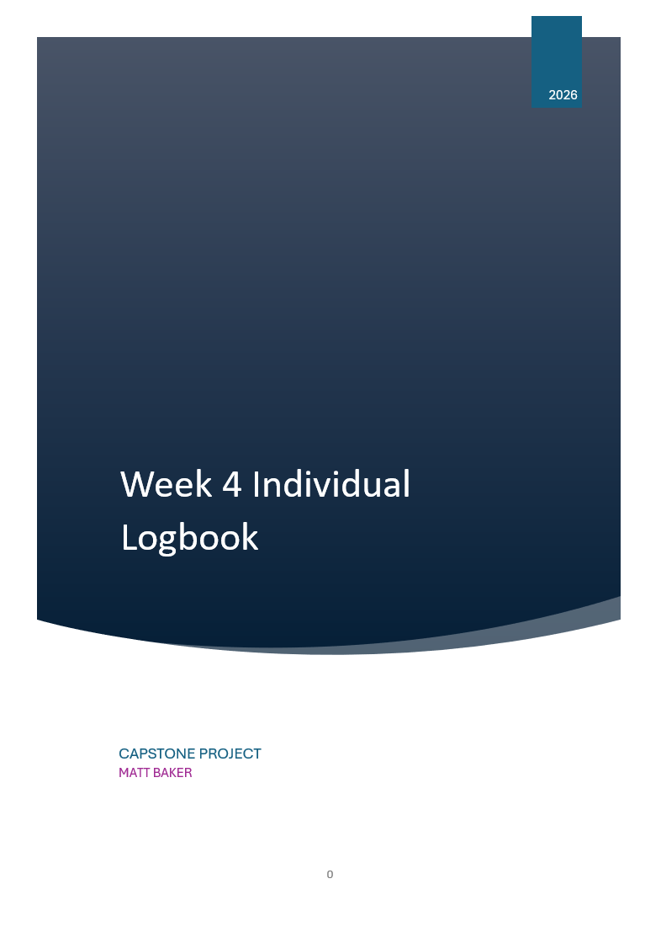

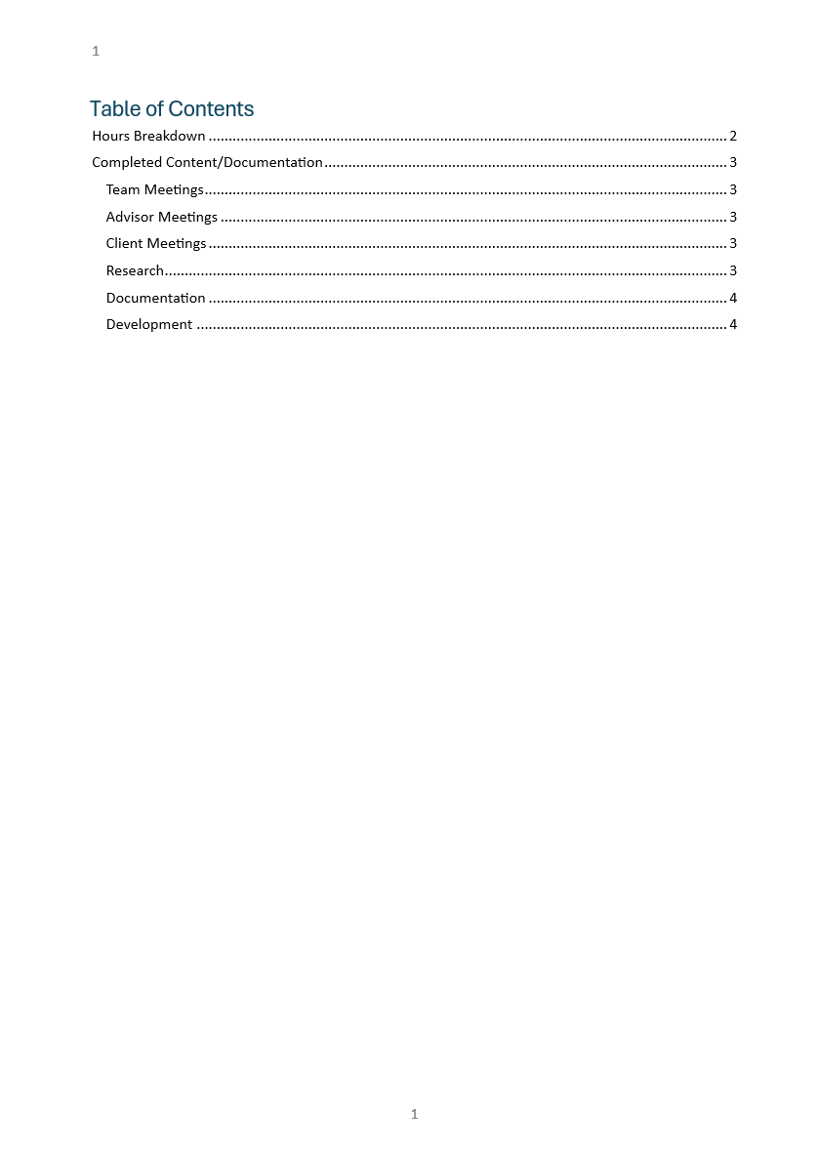

Hours Breakdown
Category | Hours completed
Team meetings | 3hrs 30 mins
Client meetings | 45mins
Advisor meetings | 1
Research | 2hrs 30 mins
Development | 1
Testing
Documentation | 7
Logbook preparation | 1
Sick leave/specific conditions
Other
Total Hours for this week | 16hrs 45min
Running total of hours completed for  Capstone | 46hrs 15min/450hr

Completed Content/Documentation
Team Meetings
Tuesday 10am-11:30am (1hr)
Attempted a meeting with Geoff, we discussed the work breakdown for the proposal instead
Friday, August 7
10:15 – 12:45 (2hrs 30 mins)
Working through the proposal with the team, generally restructuring, reformatting, and editing out/modifying irrelevant parts, ensuring everything required is in the document
Advisor Meetings
Thursday, August 6
12:00 – 1:00 (1hr)
Held our second meeting with Clement with no agenda sorted, we discussed the necessity for such things as well as signable meeting minutes to provide afterwards, the state of our project proposal, hybridization of methodologies, discussion about creating work/clarifying roles/building accountability.
Client Meetings
Wednesday, August 5
1:30-2:15 (45mins)
We held a meeting with Geoff for the purpose of documenting a meeting between client and team, including the main key problem that needs to be solved, the main expected deliverables, the “must haves”, “nice to haves” as well as the scope of the project.
Research
Wednesday, August 5
(2hrs 30mins)
Did some investigating into tool analysis efforts that follow the CTFF methodology, additionally, listened to a podcast from a 24 years’ experience forensic examiner about where AI belongs and (mostly) doesn’t belong in the IRDF pipeline

Documentation
Monday August 3rd
3:30PM-4PM (30 mins)
Added content to the project proposal, namely some description of our client and our members, as well as our roles and key responsibilities under the personnel section.
Tuesday August 4
2-4PM (2hrs)
Created the RACI matrix for the proposal, general conflict of interest statement, and updated some of the information regarding the team member’s specific roles and responsibilities.
Wednesday August 5
2:30-3:00 (30 mins)
Downloading, watching, reviewing, encoding, and uploading the edited video of our meeting with Geoff to reduce its size for upload.
3:30-4PM (30 mins)
Merged my parts of the proposal with the main document, appended and formatted the client contract.
Friday August 7
9:00 – 10:15 (1 hr 15)
Consolidating the work on our proposal so far, merging the tasks Sam and Olivia had worked on, formatting the document, and adding references
Thursday, August 6
2:00-4:15 (2hrs 15mins)
Created a template for meeting minutes and meeting agendas for advisor meetings specifically, digitized our meeting with clement, updated our week 3 minutes, and created a hierarchy for them in the git repo.
Development
Monday August 3rd
2:30PM -3:30PM (1hr)
The team collectively troubleshooted and tested access to the git repository, I added some files I was storing locally, and these commits are visible on the git.

Appendix M – MB Weekly Individual Log Period 2 Evidence
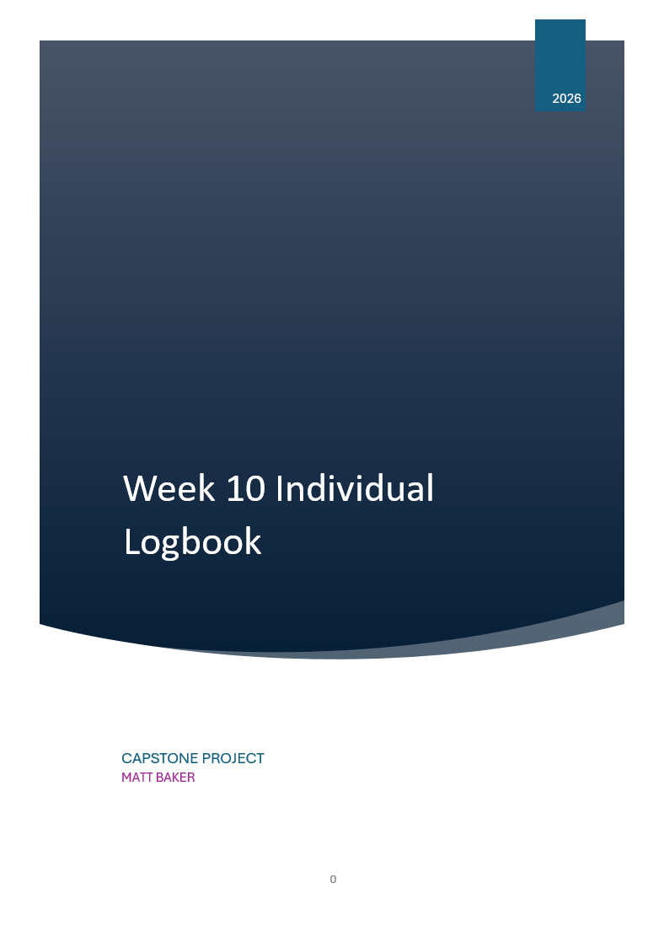

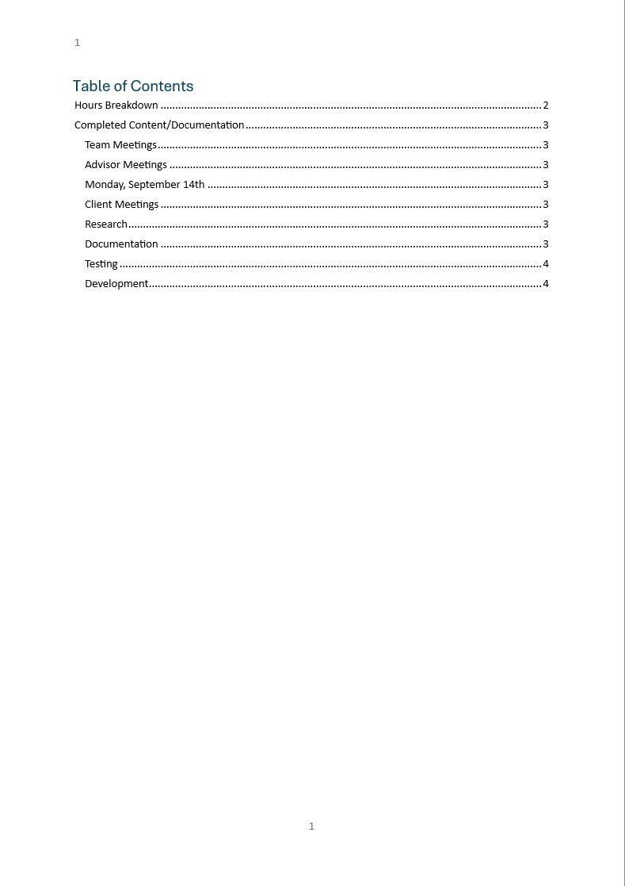

Hours Breakdown
Category | Hours completed
Team meetings | 4hrs
Client meetings | 1hr 15 min
Advisor meetings | 5hrs 15min
Research | 2hrs 45min
Development | 7hrs 30 min
Testing | 5hrs
Documentation | 2hrs 45min
Logbook preparation | 1 hr
Sick leave/specific conditions
Other
Total Hours for this week | 29hrs 30min
Running total of hours completed for  Capstone | 244hrs 30min/450hrs

Completed Content/Documentation
Team Meetings
Tuesday, September 15th
10:00 – 2:00PM (4hrs)
Audited logs clarified exact meeting hours. Discussed who would discuss each slide, did a test run through presentation, managed the git repository somewhat. Sam mentioned that some “PrivSec” guys were interested in similar technology to that which we are investigating/producing. We collectively refined the presentation, and I showed everyone how I would demonstrate both tools. We discussed the options for reducing/expanding the size of the presentation in post. We also noticed that the due date of the progress presentation differs in the upload point to its description.
Advisor Meetings
Monday, September 14th
8-10PM (2hrs)
Bryce went over our presentation, gave us some advice for each section, we discussed the inclusion of recent developments of nMap script, when and how he might demonstrate/share his existing solution of an AI-augmented nMap analysis script. He demonstrated his network tunnelling through ssh and remote viewer that in future may allow us to access resources on his network.
11-12PM (1hr)
We spoke to clement about upcoming presentation, progress on the project and confidence, discussed options for dealing with the issue of Sam and Dave’s missed weekly logs. We discussed how to document the project management portion of the project.
Friday, September 18th
9:00 – 11:15AM (2 hours 15 min)
Meeting with Bryce, all present, discussing the self-management review, other upcoming academic documents. We talked about black swan events, Stuxnet, 9/11, panamax containers, suez crisis (2021). We discussed solutions to logbook issue. 5R/STARR/5w1h reflection frameworks. Talking about permissions and usage of Wireshark and nmap. Also talked to him without dave present about how to produce a pre – engagement report which is relevant to the project because we are asking for permission from Geoff to scan the network with nMap.
Client Meetings
Tuesday, September 15th
2:30 – 3:45PM (1hr 15)
Actually meeting with Geoff, giving presentation. Discussion after about the progress of the project, permission to do nmap/wireshark scanning on school network. Discussion about limitations of AI.

Research
2hrs 45 min (see research log)
Documentation
Tuesday, September 15
5:00 – 7:15 (2hrs 15 min)
Editing, rendering, and encoding the video of the presentation we presented to Geoff. Geoff asked a lot of questions and the answering + discussion was extensive, so I included the best sections/questions. Mixing the audio (my audio was originally much higher than everyone else) was a necessary fix. I also then had to watch the video (all 15 mins) back to make sure it all sounded right.
Sunday, September 20
12:00 – 12:30 (30mins)
Created and uploaded my individual evidence of contribution to the proposal.
Testing
Wednesday, September 16
12:00 – 2:15PM (2hrs 15 min)
Based on Geoff’s question, I seek to figure out if its possible to calculate the token cost with my Foremost script. I also want to experiment with JSON formats.
Using –verbose flag shows token count and other metrics, but these statistics appear in the observer’s cli directly, I want to be able to add these up into a total token count of the ran script.
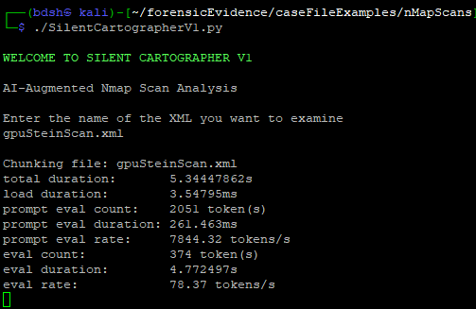
IT appears that possibly the best way to do this might to be to use capture_output subprocess feature, which hopefully works while also generating the scan chunks.

Setting the output of the first chunking command to a variable (1) with output captured directly (2) and printed out immediately after to test (3)
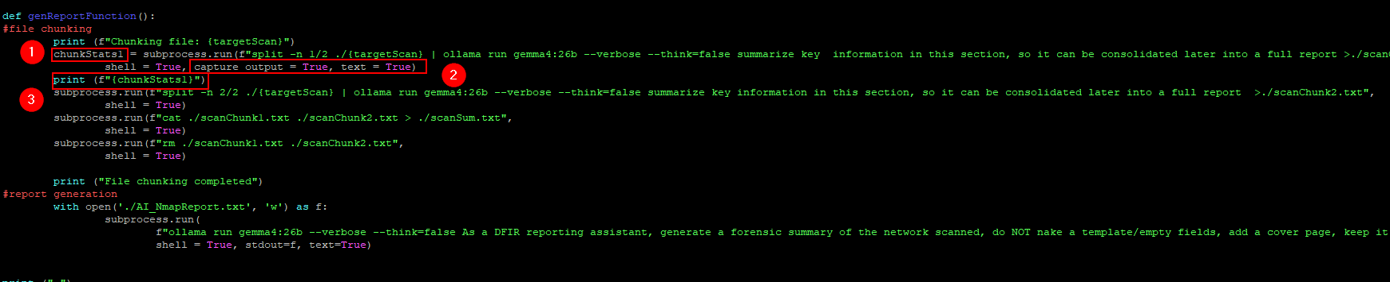
The stats are included in the variable, but python/subprocess doesn’t like 3 different types of output.
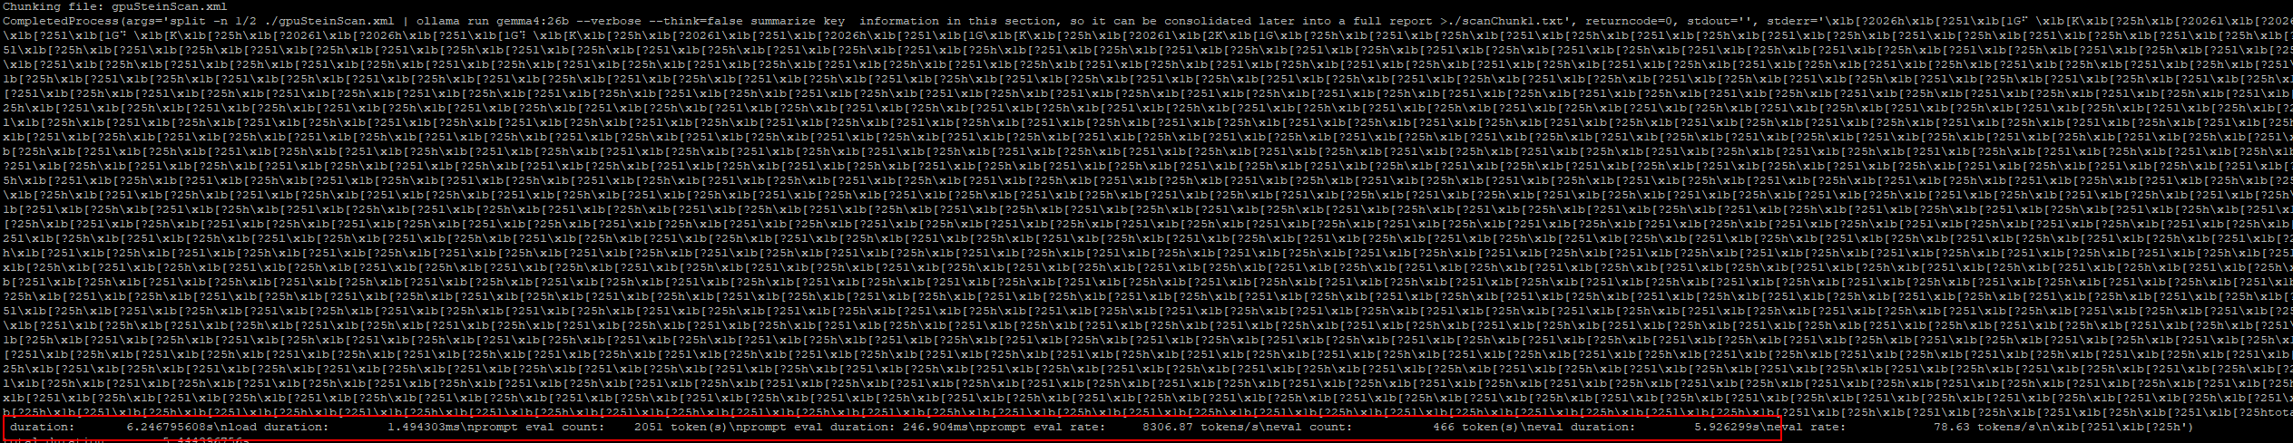
Instead of displaying as a variable, displaying as stderr, only displays what was captured by “capture_output”, which only includes the –verbose information. I also tested with stdout, because both are captured by “capture_output”, but that line did not print anything.
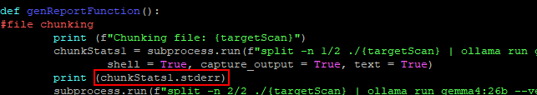
Only information I can find is that in container env, ollama outputs logs to stderr, which must include diagnostic info such as token counts.
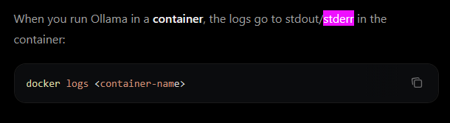
Now all I need to do it save them as an input and add them up. Because the –verbose flag contains lots of data, it will be hard to collect only the token info, I could append this text to the chunkSum.txt and have the AI calculate it, or I could collect the “prompt eval count”(input) and “eval count”(output) individually somehow.

Saturday, September 19
2:45PM – 3:30PM (45 mins)
Installing and testing an xml-JSON format conversion tool. Requires a venv. It took awhile to realise I needed to use the venv created in the same folder as the pcaps and install nmap2json there.
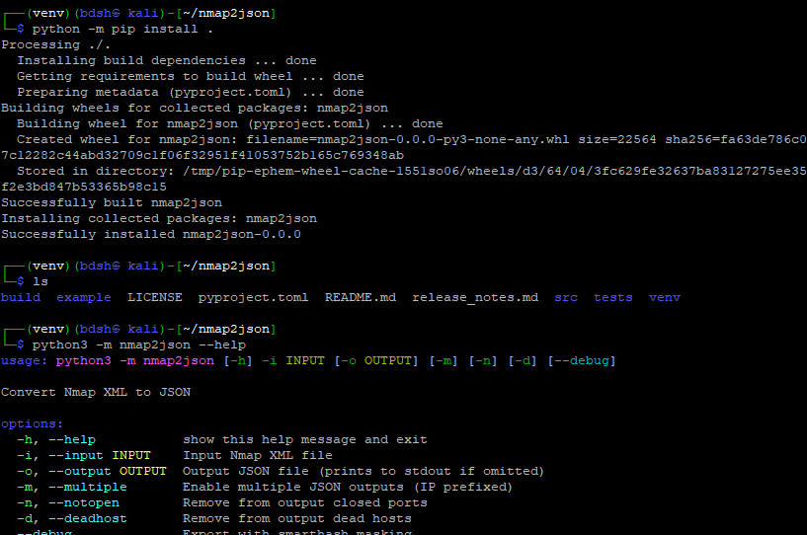
The json conversion worked, each host and its relevant ports and services is structured in a JSON list/array format.
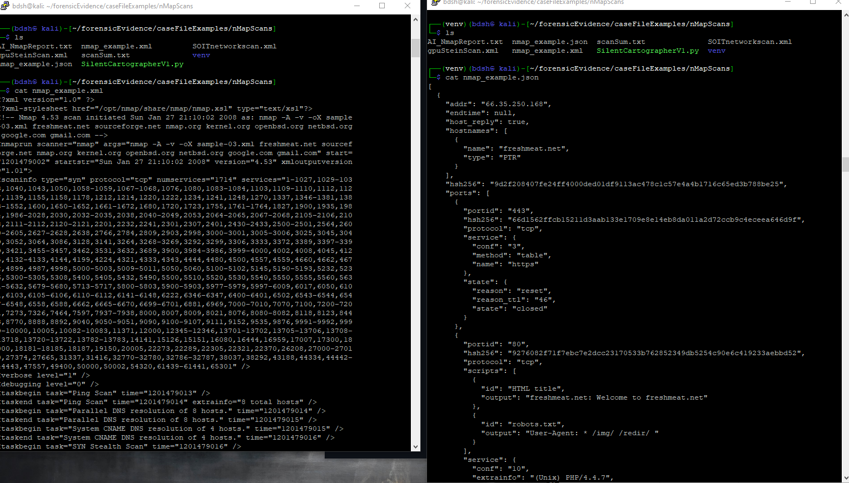

Sunday, September 20
12:45PM – 2:45PM (2hrs)
Testing different optimisations of split prompts to shorten context windows. The nmap scan of the school subnet we are permitted to scan contains massive amounts of raw data, the use of NSE sripts appends the scan with script use on every port.
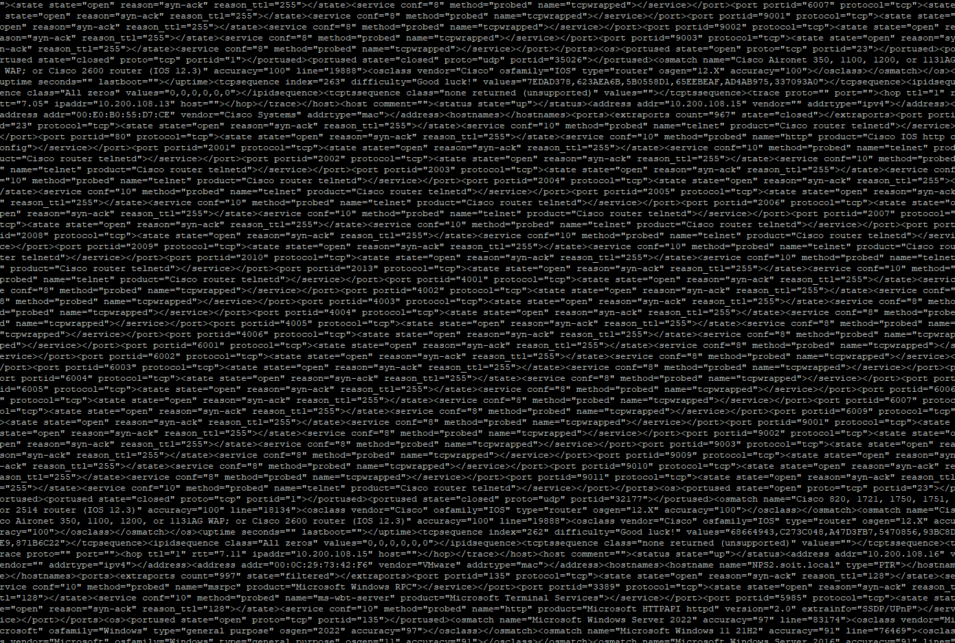
I test things like only summarizing the first two quarters.
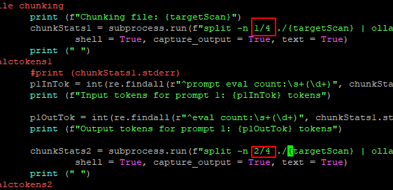

I also test the effects of different flags of the Linux “split” command, specifically on my .84 nmap scan which I know directly splits through a host name.
Consulting the manual this is the solution. It generates files instead of reading directly like using 1/2 so the code will have to be modified.
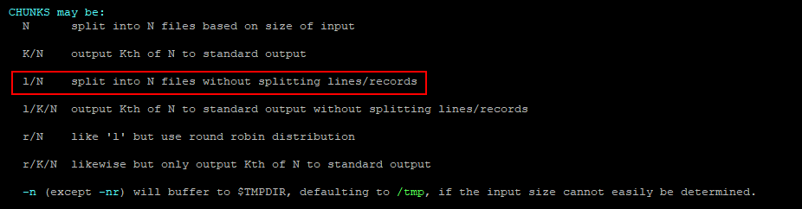
Employing this new command (1) creates 2 chunks (2) which when inspected with cat reveal the final line of the chunk will not be split on the line based on its bytes (3), preserving the actual hostname
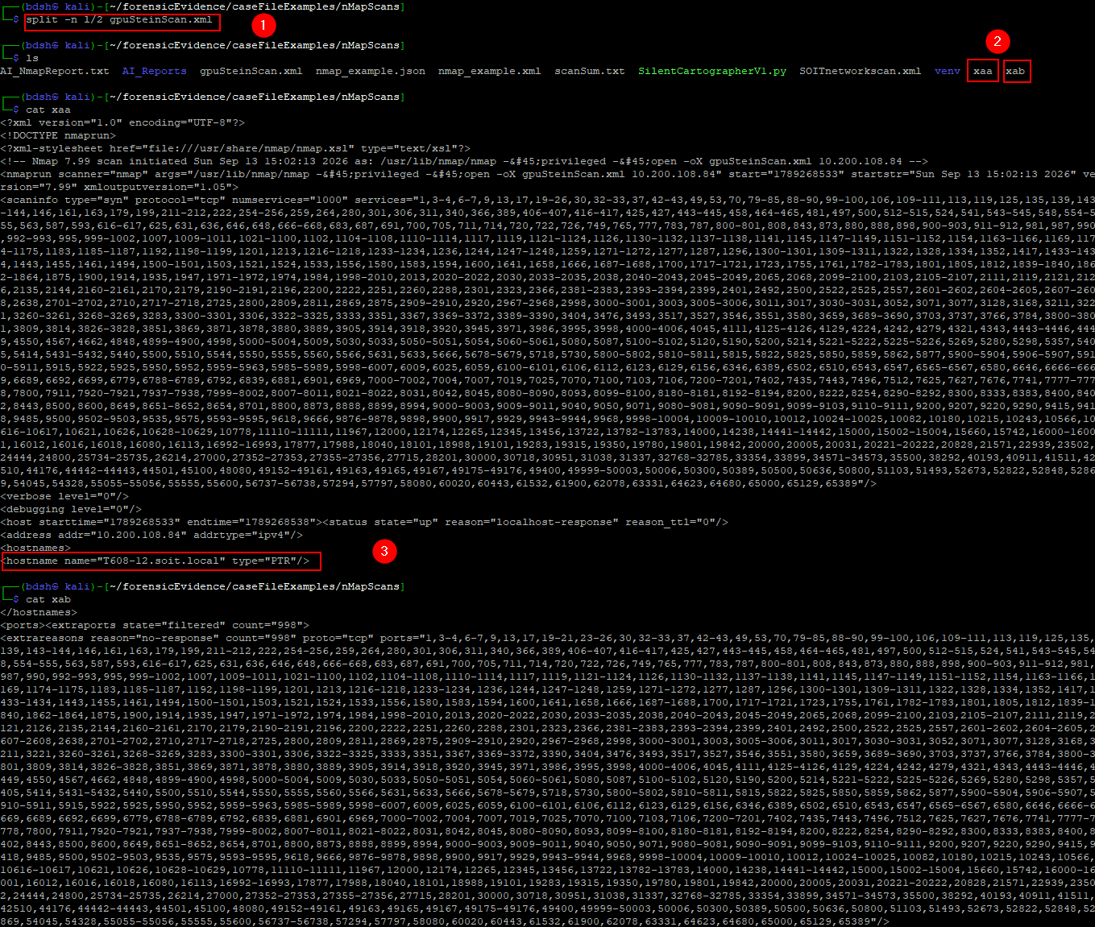
This will be implemented later.

Development
Saturday, September 19
4:00PM – 9:15PM (5hrs 15 min)
Development on SilentCartographerV1, adding up the input and output token counts for each prompt. The –verbose output from ollama is in string format so I had to figure out how to convert just the parts I want (eval and prompt_eval) token counts and add them together using “re” for regular expression modules.
https://stackoverflow.com/questions/4703390/how-to-extract-a-floating-number-from-a-string

new function couldn’t access chunkStats variables from the main function.
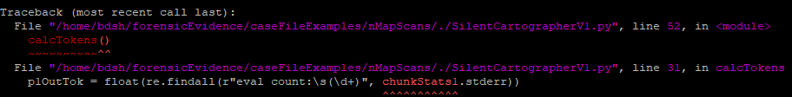
I fixed by returning them from the main function and passing them in as variables to the calctokens function. This makes the code unnecessarily complicated and although I wanted more than 1 function the calculation of total tokens might as well be in the same function they are collected from.
This was the code that used the secondary function, with changes highlighted
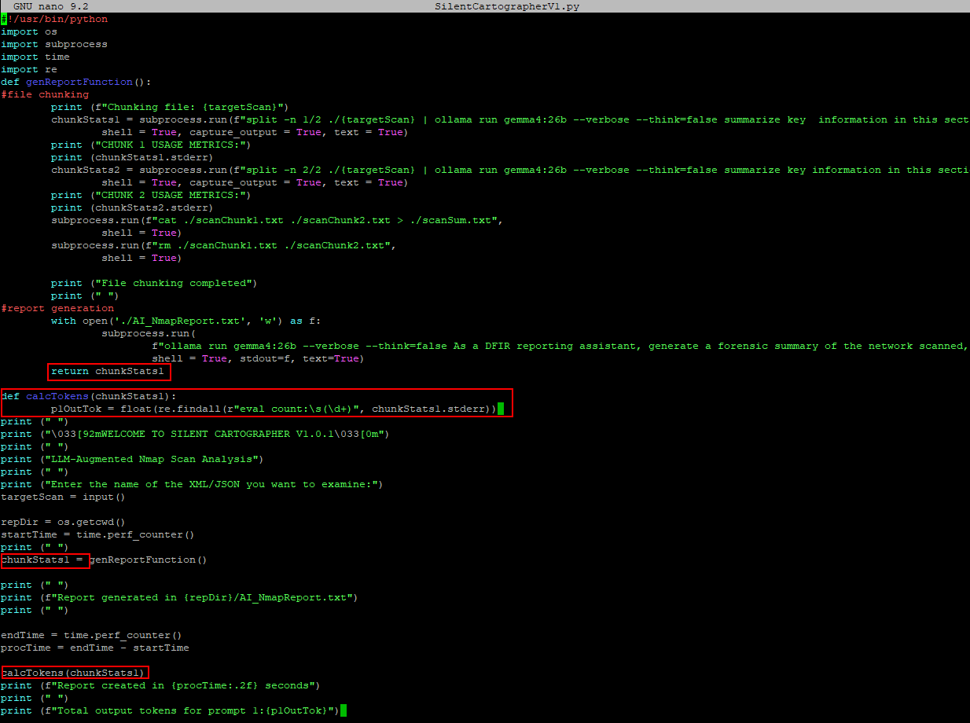

Also got this error, due to my command using “findall” which looks for the target data in lists I believe? I also realise at this point that token counts are actually round numbers (int), it’s the rates that are floats.
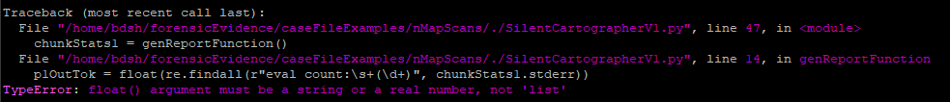
So the output of findall is a list, which means I need to specify that I want the first number in the list [0]
https://stackoverflow.com/questions/4289331/how-to-extract-numbers-from-a-string-in-python
Working line to extract the output token integer from the –verbose string variable
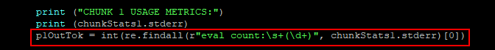
It successfully extracts the number that follows “eval count:” however, this will include the input token count “prompt eval count” (1) and display it as output token count “eval count” (2) so I have to find a way to extract the number following a string that ignores the previous “prompt” word.
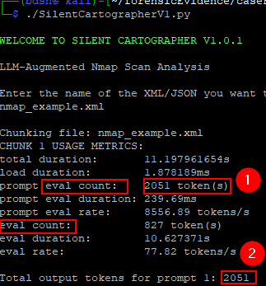
The ^ symbol means the scrutinized pattern has to start on a new line in MULTILINE mode (https://docs.python.org/3/library/re.html)

This new code successfully only matches a string after a new line, and so finds the explicit “eval count” pattern.
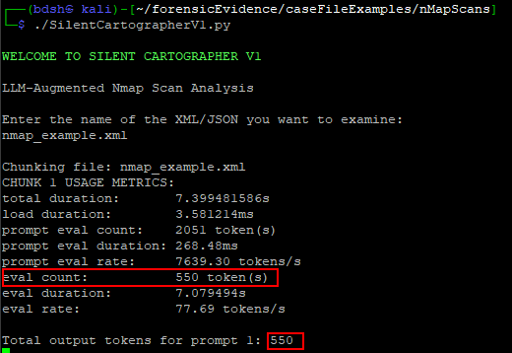
Yay it really works
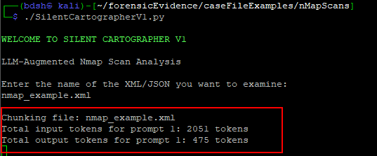
An issue I knew I would run into and took awhile to remedy is retrieving the token count for the main prompt, as I have to use “stdout” (2) to write to the main AI report (1) as f (3). And I cannot use “capture output”(4) to save the variable that saves the –verbose output as a variable (5) for processing into total token counts.
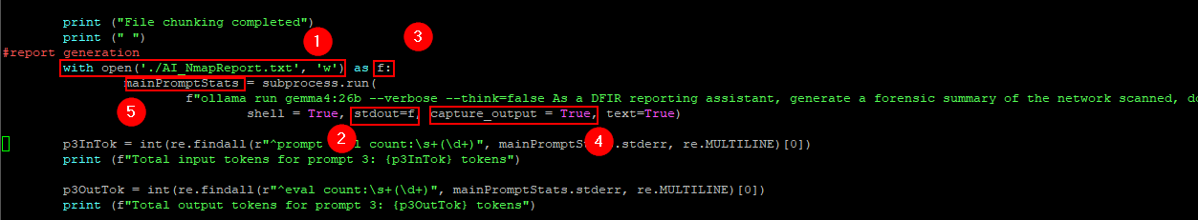

The solution was to write to the text file using stdout as f from outside of the subprocess task
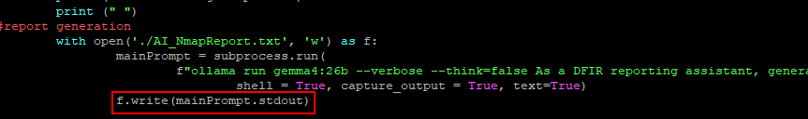
Script successfully both writes to the AI report of the summarised chunks from stdout(2) and saves the tokens from the stderr of all 3 prompts (1) although it seems like maybe prompt 1 and 2 are taking their token count from the same place, or they just happen to be identical (will troubleshoot)
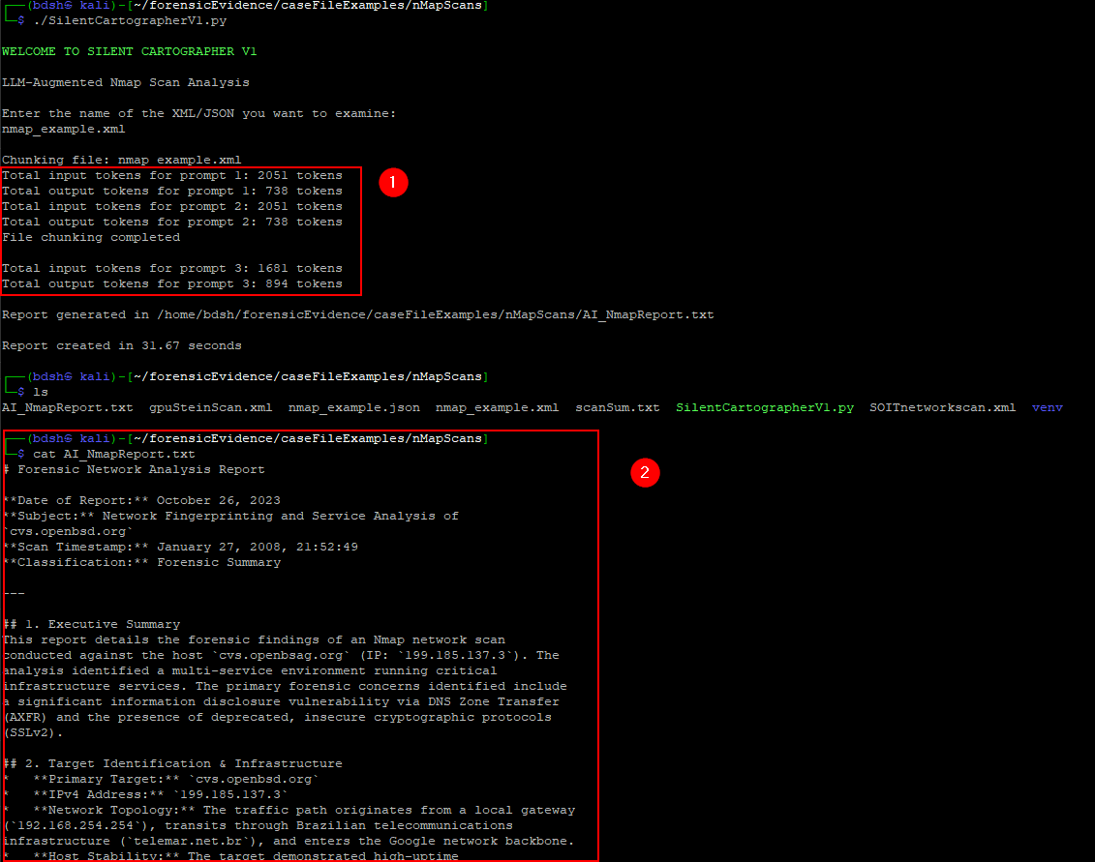

As suspected, the token counts for the first prompt (1) appear to pass via stderror extraction to both prompt 1’s token count (2) and prompt 2’s token count (3) despite the output tokens being only 445 for prompt 2 (4)
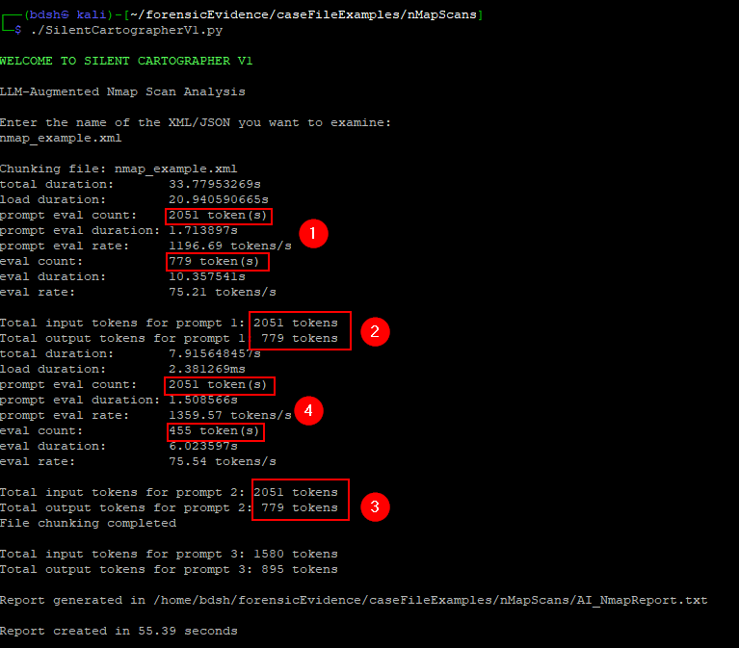
Oh woops I was printing prompt 1’s output tokens again, silly me copy pasting.
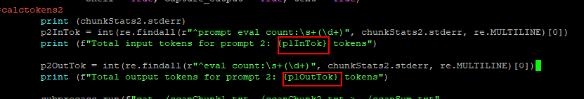
Script working as intended, with I/O token counts, now I just need to have them add together and leave the function.
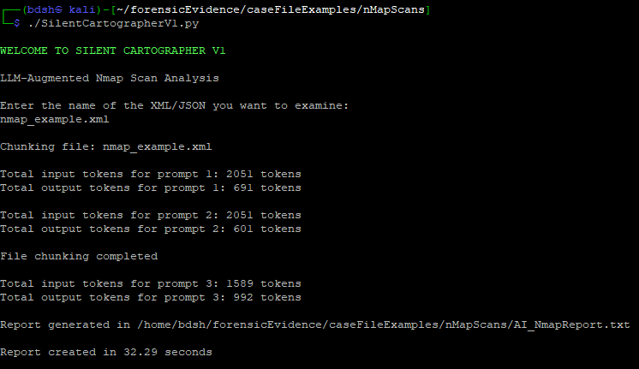
Added lines to add together the total input and output token counts as variables, then send them outside the function.
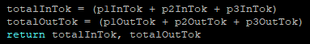
Outside of the function, have the script receive these variables when calling it (1) then print the total input, output, and calculated overall sum token count.
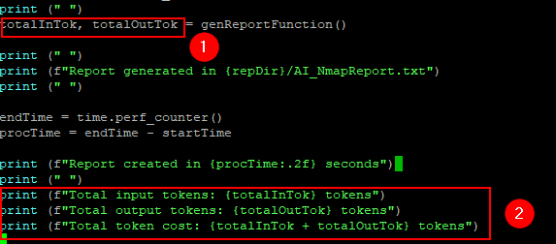
I also created a backup for all the existing scripts so far and moved them to the github.
Final output with total calculated input and output tokens. I will probably comment out the prompt-by-prompt token counts, as that was mostly for development/troubleshooting.
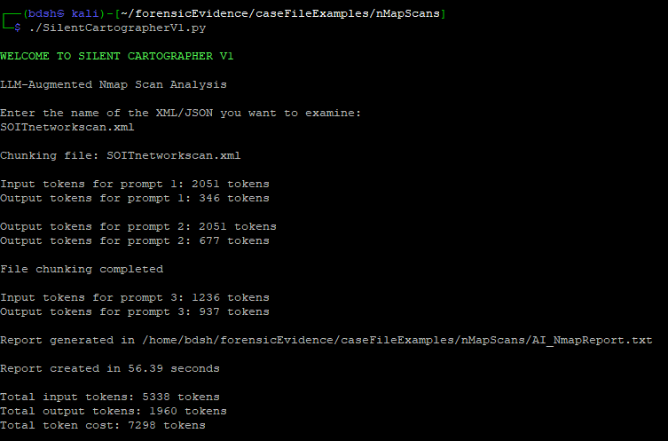

Sunday, September 20
4:15 – 6:30 (2hrs 15 mins)
Development and testing of AI reporting script for Nmap. Included the new splitting method, which uses “split -n L/2 {file}” to split a file without splitting lines to keep content intact.
Instead of directly conducting the split command and then displaying the first and second chunks to the prompt, the chunks are now generated separately (1) saved as “xaa” and xab”. Then each prompt reads the files generated respectively (2) (3).
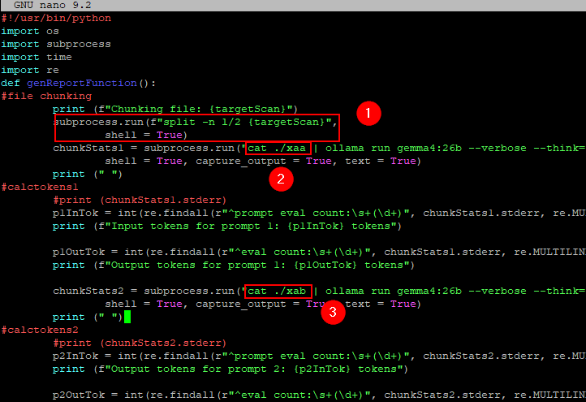
I can tell it was successful because now the output report preserves the full hostname of the target PC “T608-12.soit.local”
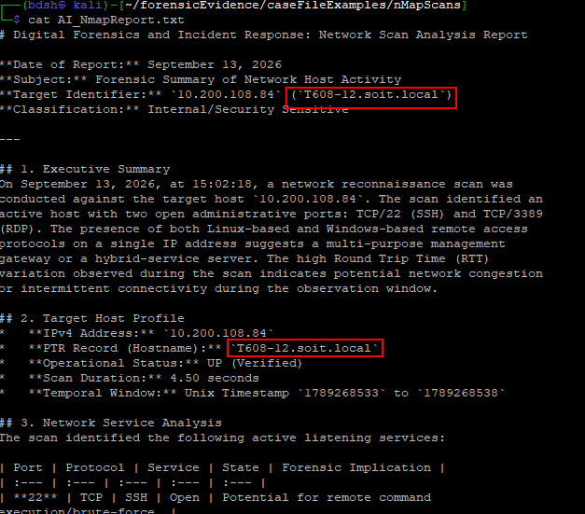
I also modified and experimented with different prompts. As the LLM sometimes doesn’t realise that its looking at an nmap scan, and it places emphasis on irrelevant data. I also want to test the team’s custom low-temperature gemma4 version.

Appendix N – SD Weekly Individual Log Period 1 Evidence
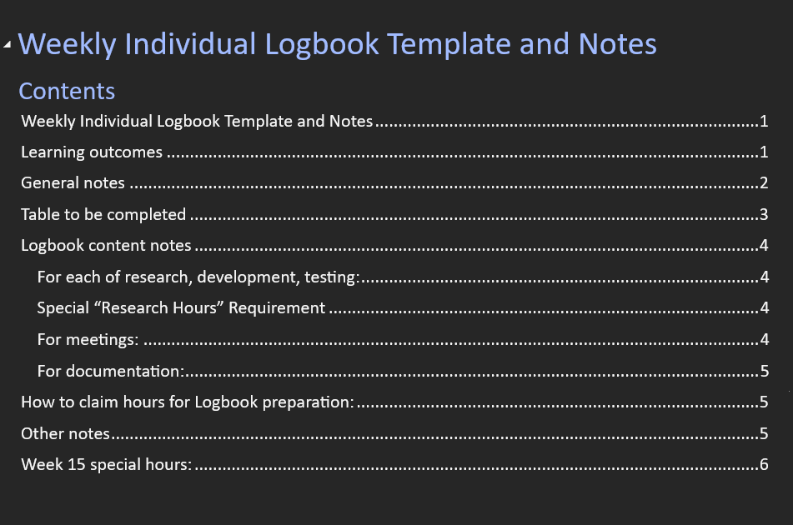
Learning outcomes
- Work collaboratively, using professional and interpersonal skills, cooperative methods and communication with team members, project sponsor and advisor.
- Apply the techniques and knowledge gained throughout the degree programme to research, analyse, design, develop, test and produce a solution
- Manage and control all aspects of the project

General notes
For our purposes, a week will start on Monday, and end on Sunday.

Each week you will upload an individual logbook.
Your logbook needs: A Cover page
A Table of Contents
A completed Table 1
Clear discussion of the work done in the week.

Do not include:
The list of Learning Outcomes
The notes in this document

Submitting incomplete logbooks, or logbooks with hours that cannot be verified, or not submitting a logbook for a week may impact your individual final grade for the Final Panel per “LO 4 Manage and control all aspects of the project”.

Also note, hours can be rejected if they are not accurate or clear.

It can also lead to an academic integrity investigation that can result in further penalties including failing the paper.

Hours Breakdown
You will need to include all hours worked per category and the running total of hours you have spent on Capstone to ensure you are on track to complete 450 hours.
Table 1 Hours to be completed
Category | Hours completed
Team meetings | 4h
Client meetings | 45m
Advisor meetings | 1h
Research | 12h35m
Development | 1h
Testing | 1h
Documentation | 4h
Logbook preparation | 1h
Sick leave/specific conditions
Other
Total Hours for this week | 24h20m
Running total of hours completed for  Capstone | 41h

Logbook content notes

Team meetings
Team meetings throughout the week plus a team meeting Friday morning before the project plan release.

Client meetings
For the client meetings we met with Geoff online to record our group video for the proposal.

Advisor Meetings
We met with Clement on Thursday to discuss the project proposal and make sure everything is up to speed before we submit everything.
Research
I Spent as much time as possible this week catching up on research that I missed out on in previous weeks in order to get up to speed with the concepts we are working on.

Documentation
Spent time documenting research as well as working on the project proposal.

Development

Testing
Spent looking at LM studio in my own time, trying to figure out how LM studio works.

Appendix O – SD Weekly Individual Log Period 2 Evidence
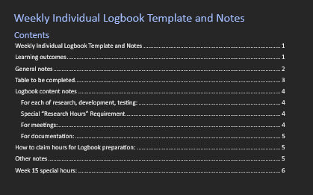

Learning outcomes
- Work collaboratively, using professional and interpersonal skills, cooperative methods and communication with team members, project sponsor and advisor.
- Apply the techniques and knowledge gained throughout the degree programme to research, analyse, design, develop, test and produce a solution
- Manage and control all aspects of the project

General notes
For our purposes, a week will start on Monday, and end on Sunday.

Each week you will upload an individual logbook.
Your logbook needs: A Cover page
A Table of Contents
A completed Table 1
Clear discussion of the work done in the week.

Do not include:
The list of Learning Outcomes
The notes in this document

Submitting incomplete logbooks, or logbooks with hours that cannot be verified, or not submitting a logbook for a week may impact your individual final grade for the Final Panel per “LO 4 Manage and control all aspects of the project”.

Also note, hours can be rejected if they are not accurate or clear.

It can also lead to an academic integrity investigation that can result in further penalties including failing the paper.

Hours Breakdown
You will need to include all hours worked per category and the running total of hours you have spent on Capstone to ensure you are on track to complete 450 hours.
Table 1 Hours to be completed
Category | Hours completed
Team meetings | 4h
Client meetings | 1h15m
Advisor meetings | 5h
Research
Development | 18h
Testing | 1h
Documentation
Logbook preparation | 1h
Sick leave/specific conditions
Other
Total Hours for this week | 30h15m
Running total of hours completed for  Capstone | 206h

Logbook content notes
Team meetings
Tuesday – Tuesday morning I showed up late to the team meeting because I had to clean up after my dog who decided my bedsheets and floor were a good place to throw up. However, during the meeting again, we prepared ourselves for the meeting, discussing who will present which slides and then we organised a test run before the meeting with Geoff. 10am – 2pm
Client meetings
Tuesday – client meeting with Geoff where we recorded the mid project presentation and then spent some time discussing with Geoff after the video was concluded. He had some interesting points to make about our project after the video concluded. 2.30 – 3:45
Advisor Meetings
Monday – advisor meeting with Bryce discussing the upcoming mid project update, he gave us some more pointers to fix in our presentation before we meet with Geoff. 8am – 10am
Monday – after our meeting with Bryce we had a meeting with clement as per the problem I had with my weekly logs and attempting to sort out a solution, we also talked about the mid project update presentation. 11 – 12pm
Friday – meeting with Bryce about starting work on the poster, final client deliverables, self-management review, version number updates, and the outcome of Dave and Sams missing logs. 9 – 11am
Research
Documentation
Development
Friday – Spent some time working on the format for my Nmap report as well as working on writing up the actual report. 5 – 9pm

Saturday – Spent some time working on my foremost report for the NINE.dd file. 12 – 6pm

Sunday – spent more time working on my foremost report, this time I went even further in the analysis using different tools to extract as much of the information inside the dd file as possible. However, this was deemed to be out of scope after a short discussion with the team. However, the time spent is not wasted, should we decided to use the extended analysis report in future. 12 – 6pm

Testing
Wednesday – scanned the SOIT network after gaining permission from Geoff. I scanned the network outside of school hours as per Geoff requirement. 11pm – 12am

